· Shenzhen Huawei Technology Co., Ltd  Research Management Documentation Center | The document number | The product version | The secret level
 |  |  | Internal disclosure
 | Product name:CPE B535-932 |  | 7 of 10

CPE B535-932 products
UT multicast Upgrade Guide
(Internal use)

Preparation: | Cwx429390 |  | date: | 2019-03-30
Audit: |  |  | date:
approve: |  |  | date:


Huawei Technologies Co., Ltd
The record
1 Overall description 3
2 Upgrade ready for 3
3 Multicast Upgrade 3
3.1 Multicast Upgrade Introduction 3
3.2 Introduction to the multicast upgrade tool 4
3.3 Upgrade process 4
3.3.1 Set up PC Network 4
3.3.2 Multicast Upgrade Software 5
3.3.3 Upgrade process progress indicator description 6
3.3.4 Upgrade troubleshooting method 7
4 Attachment 7
4.1 Multicast Tool 7

The overall description
This document describes the instructions for compiling packages and upgrades for B535-932 products.
The B535-932 product supports a variety of upgrade methods, including multicast and local upgrades that are commonly used during testing and development debugging. This article focuses on how to update the software version of the multicast upgrade.

Multicast upgrade

Introduction to multicast upgrades
Depending on the number of CPEs you need to upgrade, you can choose to use either a single upgrade or multiple upgrade methods. Single upgrades and multiple upgrades are consistent, and the main difference is the difference in network connections. A single upgrade connects the PC and the CPE gateway directly, and multiple upgrades use HUB to connect multiple CPEs and PCs. The specific upgrade connection is shown in Figures 1 and 2 below:

PC 192.168.1.100
CPE1

Figure 1 broadcasts a single upgrade wiring diagram

PC 192.168.1.100

HUB
CPE1
CPE2

CPE3

CPE4

……

CPE5

Figure 2 broadcasts multiple upgrade wiring diagrams

Introduction to the multicast upgrade tool
PC:Window operating system PC
Software: TheMulticast_Upgrade_Tool .exeof the groupcast software(see annex).
Upgrade package:VMP gets.
HUB:Multi-port HUB(only multiple upgrades required).
Network cable: Direct network cable.

The upgrade process
This section describes the method of upgrading B612 software through the multicast upgrade tool, in this operation, the process of single and multiple upgrades is the same, but the network is different, the production line generally uses multiple upgrade methods, development testing generally uses a single upgrade method.

Set up a PC network
The gateway IP address of the PC connected to HUB or CPE is set to 192.168. 1. 100,as shown in Figure 3
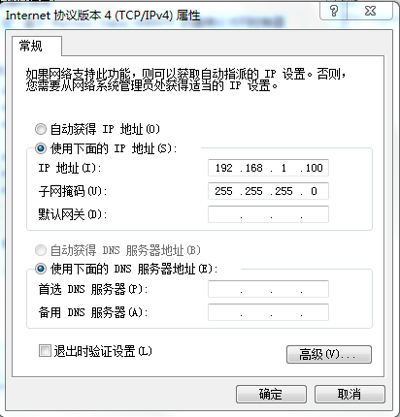
Figure 3 sets the IP address
Note: Ip settings and CPEs remain the same segment here

Multicast upgrade software
If is a normal burner upgrade or a ascending upgrade, use the tools in the attachment at the bottom of 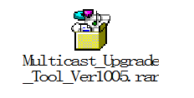this article to upgrade;
If you are upgrading a rework burner, you will need to use the tools in the attachment at the bottom of this 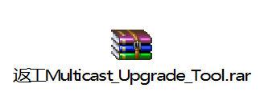article to make a reboothing tablet (note that you must first unlock it with the rework tool, as described in the Rework Guide);
After using the network cable to connect the CPE products and set up the PC IP, run the multicast upgrade software and start the multicast software settings. There are three main places to set up: network card selection settings, forced upgrade selection, and file path selection.
Network card selection settings: in the "Network Card(IP)"drop-down bar to select a network card connected to CPE or HUB, when there is no required network card in the drop-down menu, check the network connection, click "refresh" and then select;
Force upgrade selection: When the CPE single board IMEI number is empty, you need to check this option to upgrade, otherwise, the upgrade is reported incorrectly;
File path selection: Select the upgrade package to update.
Note: Upgrade Up Upgrade or BurnEr Upgrade requires both the FW and WEBUI Upgrade packages to be upgraded, set up Figure 4 below.
To upgrade a burnback, simply select the FW upgrade package for the burner, setting up Figure 5 below.
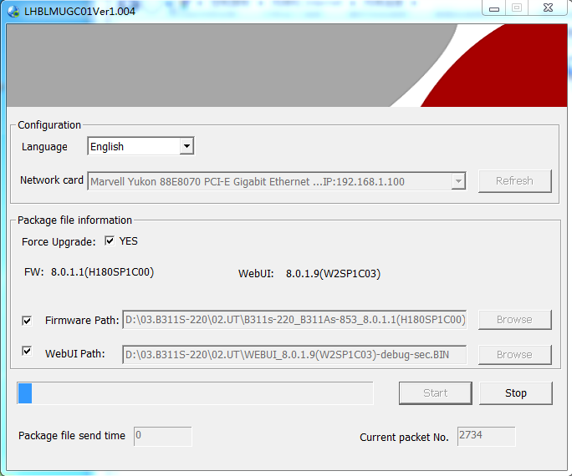
Figure 4 promotes the upgrade software interface

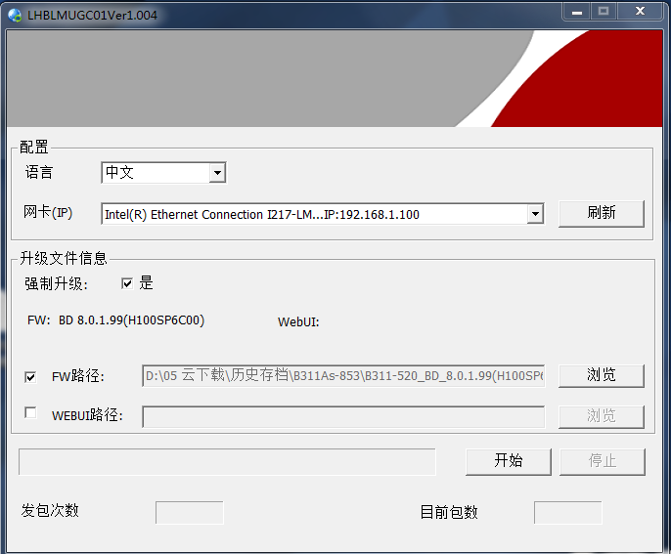
Figure 5 Group Rework Burning Tablet Software Interface
When set up, check that the version information matches the updated software version number. When the all setup checks are complete, click the Start button to start the multicast upgrade. Turn on the CPE single board power, and the single board starts and enters the multicast upgrade state.

Description of the upgrade process progress indicator
                - During the upgrade process, the status of the upgrade is identified primarily by the indicators on the front of the panel. Panel indicators from left to right are: power lamp, mode light, Wi-Fi lamp, gate light, signal 1 light, signal 2 light, signal 3 light, signal light 4,signal light 5. These lights are turned off and colored to distinguish between different upgrade states. The upgrade status indication is shown in Table 1.

                - Table 1 LED upgrade status indicates
stage | POWER | MODE | WIFI | lan | SIGNAL 1 | SIGNAL 2 | SIGNAL 3 | SIGNAL 4 | SIGNAL 5
The collection process | White is always bright | Blue is always bright | extinguish | extinguish | extinguish | extinguish | White is always bright | extinguish | extinguish
Upgrade the write flash process | White is always bright | Blue is always bright | extinguish | extinguish | extinguish | White is always bright | White is always bright | extinguish | extinguish
The upgrade was successful | White is always bright | The green is always bright | extinguish | extinguish | White is always bright | extinguish | White is always bright | extinguish | extinguish
The upgrade failed | White is always bright | Red is always bright | extinguish | extinguish | extinguish | White is always bright | White is always bright | extinguish | extinguish
Note: After the package is completed and the write flash is completed, there will be 2 restart operations on the single board;
The mode light red indicates failure, blue indicates the upgrade process, and green indicates that the upgrade was successful.
The upgrade success indicator is observed to indicate that the download is complete, the production line can be replaced with a single board for a multicast upgrade, the start test needs to point stop on the multicast software before powering off to restart the single board, otherwise the single board will automatically multicast upgrade after starting.

Upgrade the troubleshooting method
Common handling methods for failures during the upgrade process are shown in Table 2.
Table 2 How to troubleshoot
fault | The treatment method
1. The multicast upgrade has not started, the mode light is always on red, and the signal light is not any of the states in Table 1 | Check that the network connection is OK.
2, upgrade process, mode light red light always on | Check that the upgrade package is packaged in the correct way;  Check that the network connection is OK.

annex

The multicast tool

