CHAPTER 1: BACKGROUND OF PHILIPPINE HISTORY

Activity 1. Define the following terms based on your own point of view (not exactly copied from the text)

1. History
*the study of past events, particularly in human affairs:
*the whole series of past events connected with someone or something:

2. Primary source
*A ‘Primary Source’ is a document which was written or an object which was created, in the time period in which you are working. A ‘first hand’ item.

3. Secondary source
*A ‘ Secondary Sounrce’ can be defined two ways: it is anything about a historical event which was created using primary sources, and/or which was one or more stages removed from the time period and the event.

4. internal criticism
*An internal criticism is if the theory does not have a good foundation on its own terms. For example, if it is contradictory. Another reason is if it lacks common sense, but does not have a reason for defending a lack of common sense, for example.

5. external criticism
* Internal criticism looks at the reliability of an authenticated source after it has been subjected to external criticism.

6. archives
*A place or collection containing records, documents, or other materials of historical interest

7. repositories
*a place, building, or receptacle where things are or may be stored:

Activity 2. Answer the following questions on the space provided. Strictly follow the directions.

- Differentiate the following terms and give examples to support your answer.
- primary sources vs. secondary sources
*Primary sources are materials that are eyewitness accounts or as close to the original source as possible. Secondary sources are interpretations and analyses based on primary sources.

b. archives vs. museums
*An archive is a repository of records. The mission is to collect, organize, preserve, and provide access to non-current documents stored in a repository. A museum is an institution dedicated to preserving and displaying collections of physical artifacts and specimens that have value within a particular context. Exhibits are created to facilitate study and enjoyment of these physical collections.
c. internal criticism vs. external criticism
*An internal criticism is if the theory does not have a good foundation on its own terms. An external criticism is if the theory does not hold up to empirical evidence.
- Why do we have to understand the difference between internal and external criticism?
*Understanding the differences between internal and external critiques is critical for Christian apologists since any and every objection they will face will fall into one of these two categories. Moreover, if one has not sufficiently grasped these concepts, then one will be prone to conflating them or else might have trouble identifying when others commit this error.
3. What are the ways at looking in a set of data? How significant are these sets of data in history?
*In the Information Age, data is no longer scarce – it’s overpowering. The key is to sift through the overwhelming volume of data available to organizations and businesses and correctly interpret its implications. But to sort through all this information, you need the right statistical data analysis tools.

4. Give an example on how internal and external criticism can be applied in the study of Philippine history.
*Understanding the differences between internal and external critiques is critical for Christian apologists since any and every objection they will face will fall into one of these two categories. Moreover, if one has not sufficiently grasped these concepts, then one will be prone to conflating them or else might have trouble identifying when others commit this error.

- Cite some other primary and secondary sources not found in this learning material.
a. other primary sources
- Autobiographies and memoirs
- Diaries, personal letters, and correspondence
- Interviews, surveys, and fieldwork
- Internet communications on email, blogs, listservs, and newsgroups
- Photographs, drawings, and posters

b. other secondary sources
*Secondary sources were created by someone who did not experience first-hand or participate in the events or conditions you're researching. For a historical research project, secondary sources are generally scholarly books and articles. A secondary source interprets and analyzes primary sources.

- Do you consider electronics or digitized sources as primary sources? Support your answer.
*There are many different types of digital collections online, both freely available ... Primary sourcesmay be found in the following databases: Digital National Security ... Developed by the British Library, Turning the Pages allows you to virtually turn ... topically-focused digital collections of historical documents that support

7. What is meant by saying that “history matters?” Explain well.
*History connects the past with the present. History matters because it helps us as individuals and as societies to understand why our societies are the way they are and what they value. ... The answer is that History is inescapable. It studies the past and the legacies of the past in the present.

8. Is history a “dead” subject? Support your answer.
*What's the point of studying that? That's the past. That has nothing to do with my life.” Students often speak of history as a dead subject, a collection of past ...

Activity 3. React to the following statement.

1. History is inescapable.
*History Helps Us Understand Change and How the Society We Live in Came to Be The second reason history is inescapable as a subject of serious study follows closely on the first. The past causes the present, and so the future.

2.All people are living histories.

*History matters because it helps us as individuals and as societies to understand why our societies are the way they are and what they value. As Professor Penelope J Corfield says: ... All people and peoples are living histories. To take a few obvious examples: communities speak languages that are inherited from the past.

- History is not only useful, it is also essential.
*he study of history is important because it helps us understand people and societies.History offers data on information of how people and societies lived and behaved in the past.History helps provide identity.Historical data contains information of how families and even nations were formed and how the evolved while ...

4. History is to the human race whereas memory is to each man.
*Sometimes we lie to ourselves about how things happened - historians often have to look carefully to discern what in the histories are truth and what was changed to portray certain people or countries in different ways.

Activity 4. Sharpen your mind.

- Get or produce the following data and information. Print and place them on a folder for submission to your instructor.

(a) History of your school/college/university

(b) History of your city/municipality

(c) Republic Act No. 9470 document creating the National Archives of the Philippines

(d) Archives and museums in your region. List the following information.

- Name of the archives and the museums
- Location
- Mission, vision and objectives
- Names of officers and their respective positions
- primary sources and/or secondary sources kept or displayed in the archives/ museums
- photo of archives/ museums if available

- List the historical/cultural organizations in your region (where your school is located) and indicate the following information in print:

- name of the historical/ cultural organization/s and year created
- name of officers and their respective positions
- vision, mission, and objectives
- past achievements
- present progress/ projects
- problems encountered
- photo/ picture of the officers in group

Submit this document together those in number one above to your instructor.

- Why is Herodotus considered as the “Father of History”? Describe his life, works, and achievements. Then post his photo inside the box.

- His life and achievements:

Herodotus (5th century bc), Greek historian. Known as 'the Father of History'. He was the first historian to collect his materials systematically, test their accuracy to a certain extent, and arrange them in a well-constructed and vivid narrative.

- His life works and photo:

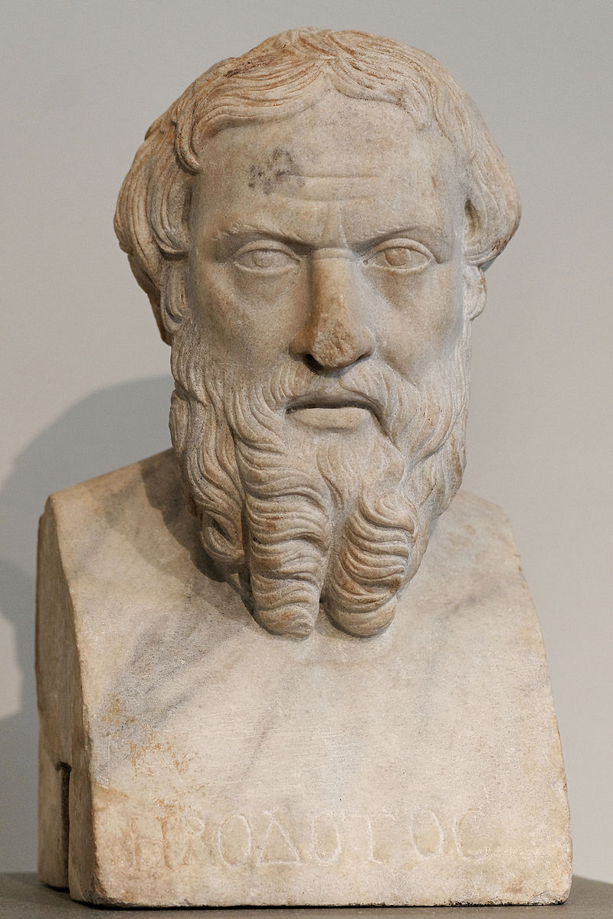
Instead of settling in one place, Herodotus spent his life traveling from one Persian territory to another. ...Herodotus spent his entire life working on just one project: an account of the origins and execution ofthe Greco-Persian Wars (499–479 B.C.) that he called The Histories.

CHAPTER 2: ANALYSIS OF SELECTED PRIMARY SOURCES

Activity 5. Define the following terms based on your own point of view (not exactly copied from the text)

1. analysis
detailed examination of the elements or structure of something.

2. critical analysis
*A critical analysis is subjective writing because it expresses the writer's opinion or evaluation of a text. Analysis means to break down and study the parts.

3. contextual analysis
*A contextual analysis is simply an analysis of a text (in whatever medium, including multi-media) that helps us to assess that text within the context of its historical and cultural setting, but also in terms of its textuality – or the qualities that characterize the text as a text.

4. content analysis
*Content analysis is a research technique used to make replicable and valid inferences by interpreting and coding textual material. By systematically evaluating texts (e.g., documents, oral communication, and graphics), qualitative data can be converted into quantitative data.

5. single text
*A single-text is a form of mediation that employs the use of a single document that ties in the often wide-ranging interests of stakeholders in a conflict.
Activity 6. Answer the following questions on the space provided. Strictly follow the directions.

1. Differentiate contextual analysis from content analysis.
*Conceptual content analysis focuses on ideas in text. Contextual content analysis lends perspective to those ideas. The two sets of scores are used together. There are a series of stages in the execution of a research design incorporating contextual/conceptual content analysis.
2. In analyzing a single text, why it is easier to analyze the text written by a single author than by a multiple author?
*A single author paper should reflect the only contribution of its sole author to its completion. But, is this always the case? Let me have my doubts.
3. One of the “don’ts” in analyzing or evaluating a primary source is to avoid recreating the author’s experience of his society. Do you agree to this statement? If yes, why? If no, why not?
*Good reading is about asking questions of your sources. Keep the following in mind when reading primary sources. Even if you believe you can't arrive at the answers, imagining possible answers will aid your comprehension. Reading primary sources requires that you use your historical imagination.
4. What is the main purpose of examining or evaluating primary sources?
*While facts and dates do matter, the main purpose of research is to evaluate the historical record in order to make an interpretive claim about an event or topic pertaining to the past.
5. Why are some texts (like primary documents) difficult to analyze?
*It is important to remember that primary source documents are often our onlysource of information about the past. As has been pointed out in previous posts, they do not tell the whole story. Furthermore, we only have those sources which have survived.
6. As a history student, why is it more important to read primary sources than secondary sources? Support your answer.
*Historians most often use written sources, but audio and visual materials as well as artifacts have become important objects that supply information to modern historians. Numerical data are explained in written form or used in support of a written statement.

7. How can you think and act like historians?
*History class should be a space where students learn to think and reason, not just memorize. We want students to be able to answer not only “What happened?” but “How ... This transforms the act of reading into a process of creative inquiry.
Activity 7. React to the following statement.

1. Texts are continually re-read and re-negotiated.
*Subjectivist: Meaning entirely in its interpretation by readers ('re-created'). ... Those who stress negotiated meaning argue that the meanings of texts are neither ... For experienced readers readingis a continual process of making inferences,.

2. Primary text can be made to speak to continuity and discontinuity, to chaos and contradictions.
*It's-Your-Text: Themes & Patterns: Primary texts sometime work together to form a pattern and a set of themes. Here the usual concern is to look for similarity and difference. Primary texts can be made to speak to continuity and discontinuity.

3.Perceptions, values, and biases are elements that are present in all texts.
*biases in our perceptions enables us to understand how we as humans relate to each other. .... lack consensus about whether such universal values exist at all. What we ... The Sacred Canopy: Elements of a Sociological Theory of Religion.

- The history student is not the intended audience of the author/writer.
*The intended audience effects all aspects of a publication. ... may be affected by who the author thinks may potentially read her/his article. ... This article from an academic journal is intended for an audience .

- The most effective and efficient way to discuss and analyze the text is to move step by step through the text.

*In writing about literature or any specific text, you will strengthen your discussion if you offer specific passages from the text as evidence.

Activity 8. Sharpen your mind.

- Divide the class into (4) groups (44 students/4 = 11 members each group). Each group elects its leader and secretary. Each group will analyze or evaluate one (1) primary source using content, contextual and author’s main argument or point of view. The analysis is centered, but not limited to authenticity, credibility, usefulness, authority and status of the author and its historical importance ans significance. The group may choose one (1) of the following primary sources.

- textbook (of any subject)

- original contract (any type)

- school record

- photograph

- application letter

- magazine/newspaper

- birth certificate/marriage certificate/baptismal certificate/death certificate

- written speech

- thesis book

The report, in written/printed form must be placed in a short folder with entries, and to be submitted to the teacher. Each report must be reported in class for discussion and oral examination.

CHAPTER 3: CONTROVERSIES AND CONFLICTING VIEWS IN PHILIPPINE HISTORY

Activity 9. Define the following terms based on your own point of view (not exactly copied from the text)

1. controversies
*disagreement, typically when prolonged, public, and heated.

2. mutiny
*A mutiny is a rebellion against authority, like when sailors overthrow the captain of a ship or when a class of 8th graders refuses to dissect a frog in biology class.

3. retraction
*the action of drawing something back or back in.

4. physical features
*physical geography. The scientific study of the natural features of the Earth's surface, especially in its current aspects, including land formation, climate, currents, and distribution of flora and fauna.

5. Cry (of Balintawak)
*The Cry of Pugad Lawin alternately and originally referred to as the Cry of Balintawak was the beginning of the Philippine Revolution against the Spanish ...

Activity 10. Answer the following questions on the space provided. Strictly follow the directions.

1. What was the “Cry of Balintawak” or “Cry of Pugadlawin”? What did it signify?
*That being the case, " Bonifacio said, "bring out your cedulas and tear them to pieces to symbolizeour determination to take up arms!" The men obediently tore up their cedulas, shouting "Long live the Philippines!" This event marked the so-called "Cry of Balintawak," which actually happened in Pugadlawin.
2. What were the reasons of Antonio Luna’s assassination?
*He was also a member of the Malolos Congress. Besides his military studies, Lunaalso studied pharmacy, literature and chemistry.
3. Who really killed or master-minded the killing of Antonio Luna? Give some proof.
*Nov 24, 2018 - Antonio Luna's and Supremo Andres Bonifacio's deaths. ... research well, and perhaps does not know much about the circumstances surrounding Luna's death. ... There is no proofthat it was indeed from Aguinaldo.

4. What was the effect of Rizal’s retraction or non-retraction controversy to the Filipino nation?
*Surely, we must put the question of retraction to rest, though Rizal is a hero, whether he retracted or not, we must investigate if he really did a turn-around. If he did not, and the documents were forgeries, then somebody has to pay for trying to deceive a nation.
5. Do you affirm or deny Rizal’s retraction? Support your answer.
*There are just some things about Rizal that I've heard that is not congruent with what I've ... The retraction letter contains Rizal's apologies and his withdrawal of the morbid ideas about ... Rizal is still Rizal: the hero who courted death “to prove to those who deny our patriotism .
6. Do you agree that the Cavite Mutiny was instigated by GOMBURZA? Support your answer.
*Sep 5, 2012 - But we should be reminded that another year is as historic as the two—1872. ... in the persons of Fathers Mariano Gomes, Jose Burgos and Jacinto Zamora (GOMBURZA). ... 1872 Cavite Mutiny: Spanish Perspective ... against the Spanish friars, “conspired and supported” the rebels and enemies of Spain.

7. Why was Luna against the forming of the revolutionary government? Support your answer.
*The Philippine Revolution also called the Tagalog War by the Spanish, was a revolution and ... The Philippine Revolution began in August 1896, when the Spanish authorities ... Bonifacio called for anattack on the capital city of Manila. .... This decline was due to lack of support from the U.S. government and lack of U.S. ...

- Was General Luna a dictator-general or not? Defend your answer.
*Antonio Luna was a military strategist who led troops against the American imperialists ... As a result, Luna died not on the battlefields of the Philippine-American War but ... in response to the 1892 banishment of Jose Rizal, but both Luna ... General Luna continued to campaign for better military discipline, ....

- Do you agree that the site of the first Catholic Mass in the Philippines was in Limasawa? Justify your answer.
*The first Catholic Mass in the Philippines was held on March 31, 1521, Easter Sunday. It was said by Father Pedro de Valderrama along the shores of what was referred to in the journals of Antonio Pigafetta as "Mazaua". Today, this site is widely believed by many to be Limasawa at the tip of ... On March 31, 1521, an Easter Sunday, Magellan ordered a Mass to be ...

- Is Limasawa Island existing at the time the Spanish expedition searched the “island”? Justify your answer.
*May 7, 2015 - Limawasa, an island municipality in Southern Leyte, is a small yet ... The Spanish too, thinking that was the answer to his question, return to tell his ... Limasawa was created into anindependent municipality on June 11, 1978 ...

- What is the Flaw Law of 1907?
*1907. No 1696.—An Act to prohibit the display of flags, banners, emblems, or devices used in the Philippine Islands for the purpose of rebellion or insurrection against the authority of the United States and the display of Katipunan flags, banners, emblems, or devices, and for other purposes.

- What does the blue color of the flag signify?
*As for the colours used, white represents hope for equality, while the blue stripe stands for peace, truth, and justice. Finally, the red stripe symbolises patriotism and valour. However, when the two stripes are interchanged, this signals that the countryis in a state of war.

- Do you agree that there should be 9 rays or a crescent in the flag instead of only 8? Justify your answer.
*Adding ninth ray of sun in PH flag would 'destroy' its historical context: historian ... Most Filipinos think of the rays as a representation of the first eight ... "These were just the 8provinces in which the Spaniards suspected that there are ..

- Do you consider General Emilio Aguinaldo a hero or a traitor? Justify your answer.
*Emilio Aguinaldo never waved the Philippine flag during the ... Antonio Luna assassination as featured by the San Francisco Call on June 14 1899 ... reputation as the 'first Filipino Quisling' (traitor) after he called on General

- Are you for or against this logical statement, “Aguinaldo could be the “brain” of Luna’s assassination since his assassination is similar to Bonifacio’s assassination?” Elucidate this statement well.
*Sep 28, 2015 - General Emilio Aguinaldo had flaws, but so did General Antonio Luna. ... and his role in Philippine history is very much alive, especially after the ... I don't think he was assassinated," said Abaya. ... The argument was this: Luna can't be considered a hero because ... "You cannot perfectly recreate the past.

Activity 11. Images/Drawings
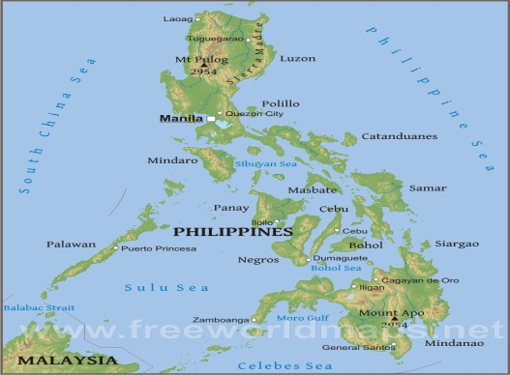
Draw/collect or cut out pictures of the following, and then paste them in the boxes. Write or describe them using the left side of the box.

- Physical features of the Philippines
Description

Outstanding physical features of the Philippines include the irregular configuration of the archipelago, thecoastline of some 22,550 miles (36,290 km), the great extent of mountainous country, the narrow and interrupted coastal plains, the generally northward trend of the river systems, and the spectacular lakes
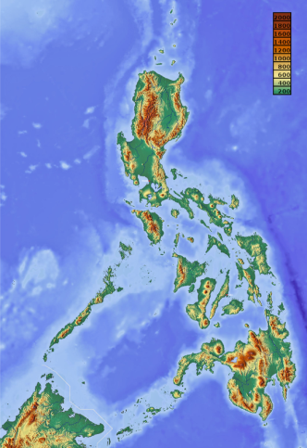
b.Location of the Philippines based on my personal view
Description

*The Philippines is an archipelago that comprises over 7,000 islands^{[7]} with a total land area of 300,000 square kilometers (115,831 sq mi).^{[1][2]} The eleven largest islands contain 95% of the total land area. The largest of these islands is Luzon at about 105,000 square kilometers (40,541 sq mi). The next largest island is Mindanao at about 95,000 square kilometers (36,680 sq mi). The archipelago is around 800 kilometers (500 mi) from the Asian mainland and is located between Taiwan and Borneo.
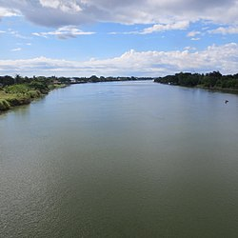

- Longest river in the Philippines
Description
- Cagayan. The River Cagayan is locally referred to as the Rio Grande de Cagayan. ...

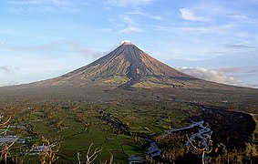

- Highest mountain in the Philippines
Description
- Apo. Mount Apo is the largest and the tallest solfataric mountain on the island of Mindanao and in all of the Philippines. ...

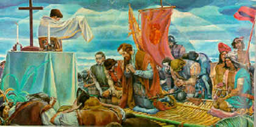
- Site of the First Mass
Description
*Ultimately, the National Historical Institute led by its chair Ambeth Ocampo recognized the historical records of Limasawa in Southern Leyte as the venue of the first Mass, held on March 31, 1521.

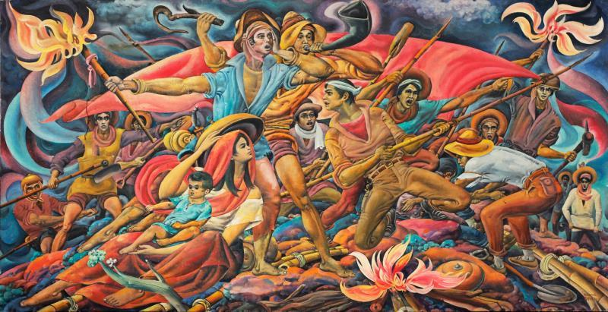

f. Cry of Balintawak
Description
*The Cry of Pugad Lawin alternately and originally referred to as the Cry of Balintawak was the beginning of the Philippine Revolution against the Spanish ...
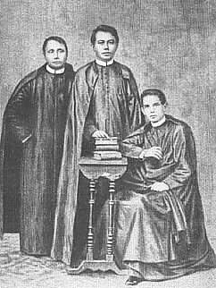
g. Mode of execution of GOMBURZA
Description
*Gomburza, alternatively spelled GOMBURZA or GomBurZa, refers to three Filipino Catholic priests (Mariano Gomez, José Burgos, and Jacinto Zamora), who wereexecuted on February 17, 1872 at Bagumbayan, Philippines by Spanish colonial authorities on charges of subversion arising from the 1872 Cavite mutiny.
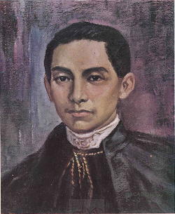
h. Bust of pictures of GOMBURZA

Brief Personal Data of Mariano Gomez
*Mariano Gómez de los Ángeles was a Filipino Catholic priest, part of the Gomburza trio who ... Mariano Gómez de los Ángeles .
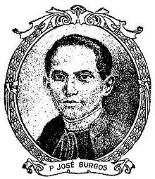

Brief Personal Data of Jose Burgos
*José Burgos. José Burgos, (born Feb. 9, 1837, Vigan, Phil.—died Feb. 17, 1872, Manila), Roman Catholic priest who advocated the reform of Spanish rule in the Philippines. ... José Rizal, the great reformer and novelist, acknowledged Burgos' contribution by dedicating his masterpiece El filibusterismo to him in 1891.

Brief Personal Data of Jacinto Zamora

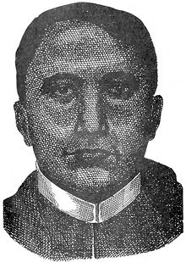
Jacinto Zamora y del Rosario (14 August 1835 - 17 February 1872) was a Filipino secular priest, part of the Gomburza trio who were falsely accused of mutiny by the Spanish colonial authorities in the Philippines in the 19th century.

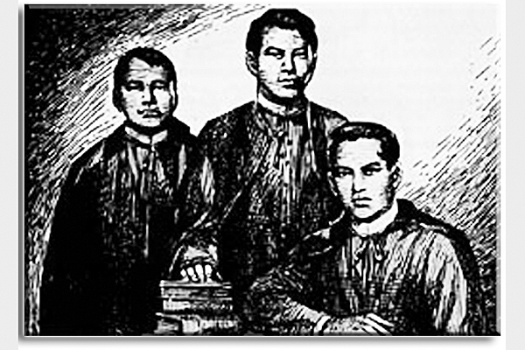

i. Cavite Mutiny (action picture)
Description
*One hundred and forty years ago, on January 20, 1872, about 200 Filipino military personnel of Fort San Felipe Arsenal in Cavite, Philippines, staged a mutiny which in a way led to the Philippine Revolution in 1896. The 1872 Cavite Mutiny was precipitated by the removal of long-standing personal benefits to the workers such as tax (tribute) and forced labor exemptions on order from the Governor General Rafael de Izquierdo.


j. The first Philippine Flag to exist
Description
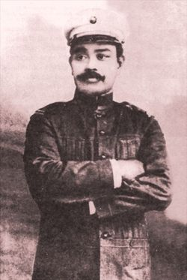
*The Philippine flag was sewn by the revolutionary junta in Hong Kong and first displayed in battle on May 28, 1898. It was formally unfurled during the proclamation of Philippine independence on June 12, 1898, by President Emilio Aguinaldo.

k. Antonio Luna’s Assassination
Description
5 June 1899, Cabanatuan City
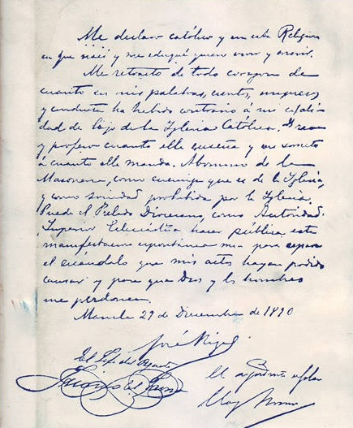
l. Rizal signing the retraction letter
Description
*The document of the retraction of Jose Rizal, too, is being hotly debated as to its authenticity. It was supposed to have been signed by Jose Rizal moments before his death. There were many witnesses, most of them Jesuits. The document only surfaced for public viewing on May 13, 1935.

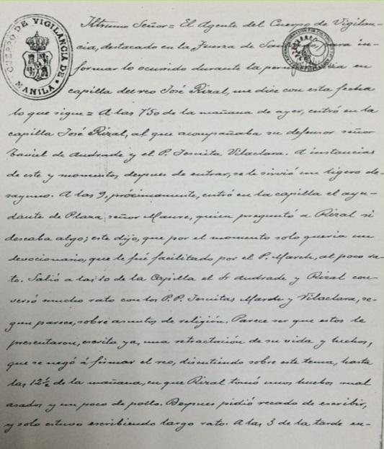
m. Retraction letter (in draft form) shown to
him inside Fort Santiago cell

Description
*History books tell most people that the first draft of the retraction was sent by Archbishop Bernardino Nozaleda to Rizal's cell in Fort Santiago the night before his execution in Bagumbayan. But Rizal was said to have rejected the draft because it was lengthy.

Activity 12. Reaction Paper
Each student is required to submit a Reaction Paper (choose 3 topics only), in printed form, consisting of 300-800 words in a long bond paper. The teacher sets the date of the submission and scoring key. The topics for the reaction paper:

- The Site of the First Mass Controversy
- Rizal’s Retraction Controversy
- Luna Assassination controversy
- The Cavite Mutiny Controversy
- The Cry of Balintawak Controversy

CHAPTER 4: CONTROVERSIES AND CONFLICTING VIEWS IN PHILIPPINE HISTORY

Activity 13. Define the following terms based on your own point of view (not exactly copied from the text).
1. corruption
*dishonest or fraudulent conduct by those in power, typically involving bribery
.
2. graft (as a serial issue)
*Graft, as understood in American English, is a form of political corruption, being the unscrupulous use of a politician's authority for personal gain. Similarly, political graft occurs when funds intended for public projects are intentionally misdirected in order to maximize the benefits to private interests.

3. poverty
*Poverty is a multifaceted concept, which may include social, economic, and political elements. Absolutepoverty, extreme poverty, or destitution refers to the complete lack of the means necessary to meet basic personal needs such as food, clothing and shelter.

4. overpopulation
*Overpopulation is an undesirable condition where the number of existing human population exceeds the carrying capacity of Earth.

5. crime
*an action or omission that constitutes an offense that may be prosecuted by the state and is punishable by law.

6. sexual abuse
*Sexual abuse, also referred to as molestation, is usually undesired sexual behavior by one person upon another. It is often perpetrated using force or by taking advantage of another.

7. incest crime
*The crime of incest is committed when people who are related to one another engage in sexual activity, get married, or live together as man and wife.

8. terrorism
*the unlawful use of violence and intimidation, especially against civilians, in the pursuit of political aims.

9. arm conflict
*a political conflict in which armed combat involves the armed forces of at least one state (or one or more armed factions seeking to gain control of all or part of the state), and in which at least 1,000 people have been killed by the fighting during the course of the conflict.

10. extrajudicial killing
*An extrajudicial killing is the killing of a person by governmental authorities or individuals without the sanction of any judicial proceeding or legal process.
Activity 14. Answer the following questions on the space provided. Strictly follow the directions.

- Differentiate the following terms and give examples to support your answer.
a. graft and corruption
*Graft, as understood in American English, is a form of political corruption, being the unscrupulous use of a politician's authority for personal gain. Similarly, politicalgraft occurs when funds intended for public projects are intentionally misdirected in order to maximize the benefits to private interests.
b. unemployment and underemployment
*Underemployment refers to highly skilled workers who, for different reasons, are working “underemployed” in low-skill, jobs and it also refers to workers working part-time who would like to work full time. ... By that referenceunemployed(/ment) means not being put to use andunderemployed (/ment) means under-utilization.
c. rape and acts of lasciviousness
*The crimes of Rape and Acts of Lasciviousness are very different from each other. Firstly, the crime of Acts of Lasciviousness is classified as a crime against chastity under Title Eleven of the Revised Penal Code. On the other hand, Rape, by virtue of Republic Act (R.A.) No. 8353 otherwise known as the Anti-Rape Law of 1997, is classified as a crime against persons.
d. violence and abuse
*Gelles and Straus show that violence and abuse are not products of mental illness but the result
of social circumstances that the majority of American families experience at one time or another,
and they explain why the family is society's most violent institution with the exception …
e. sexual violence and physical violence
*Sexual violence is any sexual act or attempt to obtain a sexual act by violence or coercion, acts .... A 2006 WHO study on physical and sexual domestic violence against women conducted across ten countries, finds that prevalence of sexual ..
f. street children and children in the streets
- *Street children are poor or homeless children who live on the streets of a city, town, or village. ...

g. traffic congestion and traffic jam
*Traffic congestion is a condition on transport networks that occurs as use increases, and is characterised by slower speeds, longer trip times, and increased vehicular queueing. ... When vehicles are fully stopped for periods of time, this is colloquially known as a traffic jam or traffic snarl-up.
h. tax evasion and tax avoidance

*Tax evasion is the illegal evasion of taxes by individuals, corporations, and trusts. ... In contrast,tax avoidance is the legal use of tax laws to reduce one's tax burden.

i. terrorism and rebellion
*Rebellion, uprising, or insurrection is a refusal of obedience or order. It refers to the open ... individual or collective, peaceful (civil disobedience, civil resistance, and nonviolent resistance) or violent (terrorism, sabotage and guerrilla warfare.).

j. working children and children working
*Child labour refers to the exploitation of children through any form of work that deprives children of their childhood, interferes with their ability to attend regular school, and is mentally, physically, socially or morally harmful.

2. “Marawi crisis was a lesson for us” - Lorenzana. What was he referring to as a “lesson”?
*The ongoing crisis in Marawi City, which has killed at least 500 people and displaced thousands as the battle rages for two months now, was a lesson learned for the defense department.
3. Do you agree that the Filipino youth today have a very shallow knowledge of history? Support your answer.
*I don’t think the youth Filipinos have shallow knowledge of history nowadays. It’s unfair to say that they are lacking interest or understanding about it. It’s just that they are more privileged to modern technology, and that its easier for them to search for information, compare to the time where you really need to read each line of the history book to find what you’re looking for. We, people of all ages, benefit from this modern way, anyway.

4. What is the most effective way to stop smoking?
- Exercise.
- Get out of the house for a walk.
- Chew gum or hard candy.
- Keep your hands busy with a pen or toothpick, or play a game in the QuitGuide app.
- Drink lots of water.
- Relax with deep breathing.
- Go to a movie.
- Spend time with non-smoking friends and family.
- Go to dinner at your favorite smokefree restaurant.

5. The Philippines has reportedly became a favorite destination of pedophiles from the U.S., Australia, and Europe. What do you think is the reason?
*Because Philippine young girls has yammy than other country…Human trafficking and the prostitution of children is a significant issue in the Philippines, often .... Time magazine reported in 1993 that Pagsanjan was a favorite destination for .... studies of these child molesters show they come mostly from Europe and are ..... The Australian Government set up the "Australian Federal Police's ...
6. Why do you think there were cases of intentional abortion in the country
*Despite advances in reproductive health law, many Filipino women ... each year from abortioncomplications, which contributes to the nation's high maternal mortality ratio. ... There are also no explicit exceptions to allow abortion in cases of rape.

7. Do you believe that marijuana can be used as a drug to some illness? If yes, why? If no, why not?
*However, the number of young people who believe regular marijuana use is risky is decreasing. ... A person then inhales the vapor, not the smoke. .... Long-term marijuana use has been linked to mental illness in some people, such as: .

8. It was reported that about 70 percent of marijuana in the world might be coming from the Cordillera region. Do you believe in that statement? Defend your answer.
*A person then inhales the vapor, not the smoke. ... People can mix marijuana in food (edibles), such as brownies, cookies, or candy, .... Long-term marijuana use has been linked to mental illness in some people, such as:.

9. It was reported that there are 8 cases of rape each da and one rape incident in every three hours in the Philippines. Do you agree with this figure? If yes, why do you think so? If no, what is your statistical figure?
*Rape is one of the most prevalent forms of violence against women (VAW) in the Philippines. Reported rape cases ranked third (13.1%) of the total reported VAW cases in ... with rape, many women victims prefer to maintain their silence and not report ..

10. Why do you think there are people who evade or avoid paying their taxes?
*Actual punishment of a lawyer can take several forms, depending on the ... In keeping with our study, however, we selected only those cases ... Appellate opinions that cite prosecutors formisconduct do not, for the ... The court did so and remanded the case to the disciplinary board forfurther proceedings.

Activity 15. Essay

Write an essay consisting of 200-500 words on the topic “Drug-Free Philippines.” It must be hand-written and submitted to the teacher. The three (3) best essays (in terms of mechanics, content, and organization criteria) will be reported in class.

Activity 16. Define the following terms based on your own point of view (not exactly copied from the text).
1. socio-political issues
*The definition of sociopolitical is something that involves both social and political factors. An example of something that is sociopolitical is the issue of environmental conservation, which is influenced by both social attitudes towards "going green" and by political policies

.2. violent
*using or involving physical force intended to hurt, damage, or kill someone or something.

3. right
*morally good, justified, or acceptable.

4. court backlog
*A court backlog is a pending case which is pending before the court for a longer period than the one prescribed. The. time-limits to deliberate cases are laid down in Article 50 of the Court Rules.

5. lower courts
*a court whose decisions may be overruled by another court on appeal.

6. political issues
* Important Issues for the Presidential Election: Anti-Trump buttons. Gun Control buttons.

7. dynasty
*a line of hereditary rulers of a country.

8. intellectual property
*a work or invention that is the result of creativity, such as a manuscript or a design, to which one has rights and for which one may apply for a patent, copyright, trademark, etc.

9. copyright law
*The United States copyright law protects "original works of authorship," fixed in a tangible medium including literary, dramatic, musical, artistic, and other intellectual works.

10. court of justice
*a tribunal that is presided over by a magistrate or by one or more judges who administer justice according to the laws. court of law, lawcourt,court. court, judicature, tribunal - an assembly (including one or more judges) to conduct judicial business.

Activity 17. Answer the following questions on the space provided. Strictly follow the directions.

1. Differentiate the following terms and give examples to support your answer.
a. bill and law
*A bill is proposed legislation under consideration by a legislature.^{[1]} A bill does not become law until it is passed by the legislature and, in most cases, approved by the executive.

b. justices and judges
*Judges work in lower level courts, such as district court and circuit court. ... Parties in those cases can appeal ajudge's decision to justices in higher courts. Justicesoperate differently than judges. Justices are found on a state's Appeals Court and Supreme Court.

c. jail and prison
*At the most basic level, the fundamental difference between jail and prison is the length of stay for inmates. Think short-term and long-term. Jails are usually run by local law enforcement and/or local government agencies, and are designed to hold inmates awaiting trial or serving a short sentence.
d. amendment and revision
*Article 14: Constitutional Amendment & Revision. § 1: Proposals by legislature; approval by electors. ... When more than one amendment shall be submitted at the same election, such amendments shall be so submitted as to enable the electors to vote on each amendment separately.
e. constitutional commission (con-con) and constitutional assemble (con-ass)
*"I'm partial to con-con, and this was my resolution before, para walang masabing self-serving provisions to extend ourselves, to extend terms, take away term limits, take away safeguards...
Kapag hindi politiko ang nagde-decide, at least masasabi nating walang nagawang self-serving," he said.
f. plebiscite and referendum
*Plebiscites. An issue put to the vote which does not affect the Constitution is called a plebiscite. A plebiscite is not defined in the Australian Constitution, the Electoral Act or the Referendum Act. ... The government is not bound by the 'result' of aplebiscite as it is by the result of a Constitutional referendum.

g. rights and privileges
*A right is granted by society to its members in order for it to function; a privilege is granted by a group or individual as either a reward for, or conditional upon, good behavior. Many people go on about their "rights" with no idea of what it means.

2. Why do you think local and national elections are marred by violence and voting chaos?
*Philippines elections marred by violence and voting chaos ... has struggled to find local volunteers to operate the machines, fearing they would be ... “I hate to say this but I think the flare-up in election-related violence could be .

3. Do you agree to the National Statistical Coordination Board (NSCB) that courts are congested with over 2 million cases yearly?
*The Philippine judiciary faces serious difficulties in addressing case backlogs as lower courts are congested with over a million cases every year, the National Statistical Coordination Board (NSCB) revealed on Friday.

4. At present, what do you think is the number of backlog cases i courts? Support your answer.
*The 1987 Constitution provides that the Supreme Court “shall” (meaning, mandatory in all jurisprudence) dispose of cases within a period of only two years. But the justices have, to this date, continued making a mockery of that provision by sitting on so many cases for as long as 15 to 20 YEARS—thus virtually reframing (amending!) that provision from the original “shall” to “may” (meaning, just a suggestion).
5. Are you for the creation of a “substrate” in the Philippines as some lawmakers consider? Justify your answer.
*We assayed each peptide for its ability to induce lipid-mixing (FRET dilution) and membrane- ... (SSIs), it is therefore essential to consider a compact wastewater treatment ... Response Surface ... United Nations Industrial Development Organization, Philippine Field Office.

6. Do you agree that there are human rights violation in the Philippines? If there are, to what extent are these violations committed? Who commits these violations?
*Human rights in the Philippines pertains to the concept, practice, and issues of human rights ... Membership in the human race is the sole qualification to obtain these rights. ... and horrendous violations of human rights during the Second World War. ..... It should also be noted, however, that there are hundreds of unsolved ...

7. Is there real energy crisis in the Philippines or just an imaginary shortage? If there is, is it an electricity shortage or just a presidential order shortage? Reason out.
*Currently, power reserves are at their lowest level, which is 10% of peak demand. ... True, coal or petroleum-fueled power stations can be added to replace the Batangas ... Renewables have only limited potential at the moment, with their intermittency problems, to solving the looming electricity shortage.

8. Why are jails and prisons congested with inmates? Do you think this condition is na extreme punishment to the inmates? Who should be blamed for the congestion?
*A HUMANITARIAN crisis is facing the Philippine corrections. ... to the brim, they are teeming with emaciated and disease-carrying bodies. ... correctional facilities in the whole world: our 605-percent congestion rate ... De facto punishment ... population growth and should not be blamed for the delay of cases.

9. Is federalism a solution to corruption and criminality? What is your point of view?
*These include “anticorruption,” “antidynasty,” “federalism,” and many other magic chants. ... He is yet to give details on the federal form of government that he wishes for thePhilippines. However, former .

10. Are you for or against same-sex marriage in the Philippines? Explain your answer.
*The Family Code of the Philippines defines marriage as "a special contract of permanent union between a man and a woman". The Constitution of thePhilippines does not prohibit same-sex marriage. Allowed for individuals but not allowed for same-sex couples.

Activity 18. Essay

Write an essay consisting of 300-600 words in handwriting. The quality of the essay is evaluated according to its mechanics, content, and organization. The individual essay is submitted to the teacher on a particular date and time set by the teacher.
The students may focus on one socio-political issue or they may select the issue they want to write about.

Activity 19. Define the following terms based on your own point of view (not exactly copied from the text).
1. environment
_________________________________________________________________________________________________________________________________________________________________________________________________________________________________

2. health
_________________________________________________________________________________________________________________________________________________________________________________________________________________________________

3. sports
_________________________________________________________________________________________________________________________________________________________________________________________________________________________________

4. segregation
_________________________________________________________________________________________________________________________________________________________________________________________________________________________________

5. vaccines
______________________________________________________________________________________________________________________________________________________
___________________________________________________________________________
6. mining
_________________________________________________________________________________________________________________________________________________________________________________________________________________________________

7. malnutrition
_________________________________________________________________________________________________________________________________________________________________________________________________________________________________

Activity 20. Answer the following questions on the space provided. Strictly follow the directions.

- Differentiate the following terms and give examples to support your answer.
a. labor and labor contracting
_________________________________________________________________________________________________________________________________________________________________________________________________________________________________
b. endo and contractualization
_________________________________________________________________________________________________________________________________________________________________________________________________________________________________
c. sports and games
_________________________________________________________________________________________________________________________________________________________________________________________________________________________________
d. malnutrition and undernutrition
_________________________________________________________________________________________________________________________________________________________________________________________________________________________________

e. sexual violence and physical violence
_________________________________________________________________________________________________________________________________________________________________________________________________________________________________

f. HIV and AIDS
_________________________________________________________________________________________________________________________________________________________________________________________________________________________________

- Give some other cultural values and cultural practices not found in this book.

a. cultural values
- ______________________________________________________________________
- ______________________________________________________________________
- ______________________________________________________________________

b. Cultural practices
1. ______________________________________________________________________
2. ______________________________________________________________________
3. ______________________________________________________________________

3. Why are the cutting of trees in private lands prohibited?
_________________________________________________________________________________________________________________________________________________________________________________________________________________________________

4. Should the cutting of logs and other forest trees be selectively/partially banned or totally banned? What is your idea to this issue?
_________________________________________________________________________________________________________________________________________________________________________________________________________________________________

5. Do you agree to the negative effects of frequently using mobile phones? Defend your answer.
_________________________________________________________________________________________________________________________________________________________________________________________________________________________________

6. Why do some household families do not separate their waste materials?
_________________________________________________________________________________________________________________________________________________________________________________________________________________________________

7. What is wrong with Dengvaxia?
_________________________________________________________________________________________________________________________________________________________________________________________________________________________________

8. Why do you think HIV positive cases are increasing?
_________________________________________________________________________________________________________________________________________________________________________________________________________________________________

Activity 21. Essay

Write an essay consisting of 150-300 words in handwritten form. Submit this in a date scheduled by the teacher. The essay is graded according to organization, content, and mechanics. The three (3) best essays may be read in class. Topics that can be selected for an essay are:

- Waste Segregation in Our Country
- The Health Hazards of Mobile Phones
- The School as a No Smoking Zone
- The Firecracker Ban: How Effective is the Ban?
- Prohibition of Cutting of Trees: Its Positive and Negative Impact

Activity 22. Define the following terms based on your own point of view (not exactly copied from the text).
1. cultural values
_________________________________________________________________________________________________________________________________________________________________________________________________________________________________

2. culture
_________________________________________________________________________________________________________________________________________________________________________________________________________________________________

3. cultural heritage
_________________________________________________________________________________________________________________________________________________________________________________________________________________________________

4. historical landmark
_________________________________________________________________________________________________________________________________________________________________________________________________________________________________

5. folk songs and folk dances
______________________________________________________________________________________________________________________________________________________
___________________________________________________________________________

Activity 23. Answer the following questions on the space provided. Strictly follow the directions.

1. Differentiate the following terms and give examples to support your answer.
a. cultural values and cultural practices
_________________________________________________________________________________________________________________________________________________________________________________________________________________________________
b. historical landmarks and historical sites
_________________________________________________________________________________________________________________________________________________________________________________________________________________________________
c. historical structures and historical structures
_________________________________________________________________________________________________________________________________________________________________________________________________________________________________
d. ningas cogon and bahala na attitude
_________________________________________________________________________________________________________________________________________________________________________________________________________________________________

e. amor proprio and hiya complex
_________________________________________________________________________________________________________________________________________________________________________________________________________________________________

2. Give some other cultural values and cultural practices not found in this book.

a. “The Filipinos are lazy”
1. ______________________________________________________________________
2. ______________________________________________________________________
3. ______________________________________________________________________

b. “There is a good effect of Mañana habit”
1. ______________________________________________________________________
2. ______________________________________________________________________
3. ______________________________________________________________________

c. “The gaya-gaya practice is not bad or wrong all the time”
1. ______________________________________________________________________
2. ______________________________________________________________________
3. ______________________________________________________________________

Activity 24. Essay

Write an essay consisting of 150-300 words on any of the following topics. This essay will be handwritten and submitted to the teacher for grading purposes.

- Karma: True or False
- The Unforgotten Landmarks/Historical Place in our Region
- Promotion and Preservation of Cultural Values and Practices in our Town/City

Activity 25. Define the following terms based on your own point of view (not exactly copied from the text).
1. cultural values
_________________________________________________________________________________________________________________________________________________________________________________________________________________________________

2. culture
_________________________________________________________________________________________________________________________________________________________________________________________________________________________________

3. cultural heritage
_________________________________________________________________________________________________________________________________________________________________________________________________________________________________

4. historical landmark
_________________________________________________________________________________________________________________________________________________________________________________________________________________________________

5. folk songs and folk dances
______________________________________________________________________________________________________________________________________________________
___________________________________________________________________________

Activity 26. Answer the following questions on the space provided. Strictly follow the directions.

1. Differentiate the following terms and give examples to support your answer.
a. cultural values and cultural practices
_________________________________________________________________________________________________________________________________________________________________________________________________________________________________
b. historical landmarks and historical sites
_________________________________________________________________________________________________________________________________________________________________________________________________________________________________
c. historical structures and historical structures
_________________________________________________________________________________________________________________________________________________________________________________________________________________________________
d. ningas cogon and bahala na attitude
_________________________________________________________________________________________________________________________________________________________________________________________________________________________________

e. amor proprio and hiya complex
_________________________________________________________________________________________________________________________________________________________________________________________________________________________________

2. Give some other cultural values and cultural practices not found in this book.

a. “The Filipinos are lazy”
1. ______________________________________________________________________
2. ______________________________________________________________________
3. ______________________________________________________________________

b. “There is a good effect of Mañana habit”
1. ______________________________________________________________________
2. ______________________________________________________________________
3. ______________________________________________________________________

c. “The gaya-gaya practice is not bad or wrong all the time”
1. ______________________________________________________________________
2. ______________________________________________________________________
3. ______________________________________________________________________

Activity 27. Essay

Write an essay consisting of 150-300 words on any of the following topics. This essay will be handwritten and submitted to the teacher for grading purposes.

1. Karma: True or False
2. The Unforgotten Landmarks/Historical Place in our Region
3. Promotion and Preservation of Cultural Values and Practices in our Town/City

Activity 28. Define the following terms based on your own point of view (not exactly copied from the text).
1. Constitution
_________________________________________________________________________________________________________________________________________________________________________________________________________________________________

2. agrarian reform
_________________________________________________________________________________________________________________________________________________________________________________________________________________________________

3. Revolutionary government
_________________________________________________________________________________________________________________________________________________________________________________________________________________________________

4. tax
_________________________________________________________________________________________________________________________________________________________________________________________________________________________________

5. taxation
______________________________________________________________________________________________________________________________________________________
___________________________________________________________________________

Activity 29. Answer the following questions on the space provided. Strictly follow the directions.

1. Differentiate the following terms and give examples to support your answer.
a. agrarian reform and land reform
_________________________________________________________________________________________________________________________________________________________________________________________________________________________________
b. revenue and capital
_________________________________________________________________________________________________________________________________________________________________________________________________________________________________
c. Constitution and law
_________________________________________________________________________________________________________________________________________________________________________________________________________________________________
d. tariff and custom duties
_________________________________________________________________________________________________________________________________________________________________________________________________________________________________

e. issues and problems
_________________________________________________________________________________________________________________________________________________________________________________________________________________________________

2. Why is tax a burden? Support your answer.
_________________________________________________________________________________________________________________________________________________________________________________________________________________________________

3. Why are the issues in the implementation of the agrarian reform law still persist today?
_________________________________________________________________________________________________________________________________________________________________________________________________________________________________

4. Why are the above mandated topics included or integrated in the study of Philippine History? Support your answer.
_________________________________________________________________________________________________________________________________________________________________________________________________________________________________

5. What is meant by the statement that the 1987 Philippine Constitution has a “lingering shadow of martial law?”
_________________________________________________________________________________________________________________________________________________________________________________________________________________________________

Activity 30. Essay

Write an essay consisting of 150-300 words on a piece of paper (white or yellow) and in your own handwriting. Be careful with the mechanics, content, and organization of ideas. The three (3) best essays may be read in class. Select from any of these titles:

- My Role in the Promotion of Tax Payment
- My Role in the Agrarian Reform Program in the Government
- My Responsibility as a Good Citizen of the Community

CHAPTER 5: PROMOTING AND PRESERVING HISTORICAL AND CULTURAL HERITAGE

Activity 31. Define the following terms based on your own point of view (not exactly copied from the text).
1. conservative
_________________________________________________________________________________________________________________________________________________________________________________________________________________________________

2. interview
_________________________________________________________________________________________________________________________________________________________________________________________________________________________________

3. people power
_________________________________________________________________________________________________________________________________________________________________________________________________________________________________

4. park
_________________________________________________________________________________________________________________________________________________________________________________________________________________________________

5. landmark
______________________________________________________________________________________________________________________________________________________
___________________________________________________________________________
6. limestone
_________________________________________________________________________________________________________________________________________________________________________________________________________________________________

7. church ruins
_________________________________________________________________________________________________________________________________________________________________________________________________________________________________

8. cathedral
_________________________________________________________________________________________________________________________________________________________________________________________________________________________________

9. baroque church
_________________________________________________________________________________________________________________________________________________________________________________________________________________________________

10. ceremony
______________________________________________________________________________________________________________________________________________________
___________________________________________________________________________

Activity 32. Answer the following questions on the space provided. Strictly follow the directions.

1. Differentiate the following terms.
a. church and cathedral
_________________________________________________________________________________________________________________________________________________________________________________________________________________________________
b. ritual and ceremony
_________________________________________________________________________________________________________________________________________________________________________________________________________________________________
c. landmarks and sites
_________________________________________________________________________________________________________________________________________________________________________________________________________________________________
d. museum and archive
_________________________________________________________________________________________________________________________________________________________________________________________________________________________________

e. museum and art gallery
_________________________________________________________________________________________________________________________________________________________________________________________________________________________________

f. archives and museums
_________________________________________________________________________________________________________________________________________________________________________________________________________________________________

g. historical sites and archaeological sites
_________________________________________________________________________________________________________________________________________________________________________________________________________________________________

h. marriage and wedding
_________________________________________________________________________________________________________________________________________________________________________________________________________________________________

i. shrine and monument
_________________________________________________________________________________________________________________________________________________________________________________________________________________________________

2. What makes a shrine or site a UNESCO world heritage? Give examples.
_________________________________________________________________________________________________________________________________________________________________________________________________________________________________
- cultural values
_________________________________________________________________________________________________________________________________________________________________________________________________________________________________

(b) traditional practices; and
_________________________________________________________________________________________________________________________________________________________________________________________________________________________________

(c) cultural heritage?
_________________________________________________________________________________________________________________________________________________________________________________________________________________________________

(d) Is “moro-moro” an indigenous cultural practices? How is it performed?
_________________________________________________________________________________________________________________________________________________________________________________________________________________________________

(e) What does this statement mean “Archives are the secretion of an organism?
_________________________________________________________________________________________________________________________________________________________________________________________________________________________________

(f) Aside from what is found in this text, kindly give additional rituals in the Philippines?

- _________________________________________________________________________
- _________________________________________________________________________
- _________________________________________________________________________
- _________________________________________________________________________
- _________________________________________________________________________

(g) Why are record and documents preserved? Give examples of records and documents?
_________________________________________________________________________________________________________________________________________________________________________________________________________________________________

(h) Do you believe in “kutkot”? Why?
_________________________________________________________________________________________________________________________________________________________________________________________________________________________________

(i) Is the U.S. Library of Congress a library, a museum, an archive, or a lawmaking body? What is its role in the Philippine history?
_________________________________________________________________________________________________________________________________________________________________________________________________________________________________

(j) What is a computer library? Are there sources of information in this library? Explain.
_________________________________________________________________________________________________________________________________________________________________________________________________________________________________

(k) Who are the ultimate beneficiaries of all activities affecting cultural communities?
_________________________________________________________________________________________________________________________________________________________________________________________________________________________________

(l) Why do we have to protect and conserve the natural cultural history of the nation?

Activity 33. Essay

Write an essay consisting of 200-500 words on topic “How to Preserve My Culture” on a long bond paper. Write on your own handwriting. Your teacher will rate the quality of your essay. The three (3) best essays may be read in class.

