
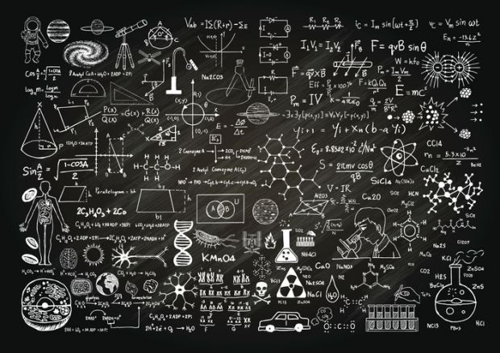
`

IN LOVE
WITH
PHYSICS ?
CUARTEROS MAPAGDALITA VILLA DELREY LEYNES
PARISUKAT

Limits allow us to formalize an idea that we can compare expressions by computing a sequence of approximation that could bring us closer to the answer that we wanted.
Physics is a study that has a more realistic view of things. However, things realist city is somewhat a hindrance to what may be possible. Physics has its own limits too it has boundaries. For instance, you have a radioactive nuclei and you want to find out when it decays completely. The equation is$N=NO e^{^}-\left(k. t\right)$, where T is half-life, t is time and NO is the original amount. You will find out that no matter how big a t you take you never get O as an answer. What you can do is take N as t approaches infinity. Eventually, you will come up with O. This is impossible in physics, however, limits help reach beyond the boundaries of Physics.

Limit is capable of taking a value from a point where in the point can be made to approach progressively towards something of a value as desired. Physics as I’ve mentioned, does not provide this kind of allowance for us. Limits extend the reach of human comprehension to further solve problems more effectively. In away. Physics is only limited to realistic values. Whereas with the use of limits. We can produce a more precise value. This however is not physically possible but theoretically is.


The speed of an object is
$$v=\frac{∆x}{∆t}$$

But in many cases we want the speed in a certain moment in time one example of that is the objects velocity. To get that we need a number that approaches to that’s when we need limit the instantaneous velocity

$$v=\frac{dx}{dt}=\lim_{t→0}{\frac{f\left(t\right)-f(o)}{t-0}}$$

If f (t) gives space at the moment than it is equal to

$$v=\lim_{t→0}{\frac{f\left(t\right)-f(o)}{t-0}}$$

This is the application of limits to physics are the basics of calculus. They are not used directly in practice but the concepts of limits are widely used.

Example
A ball is thrown downward from a design of 512 feet with a velocity of 64 feet per second. How long will it take for the ball to reach the ground?

From calculus we know that given the position function of an object that the velocity of the object is the first limit of the position function and the acceleration of the object is the second limit of the position function.

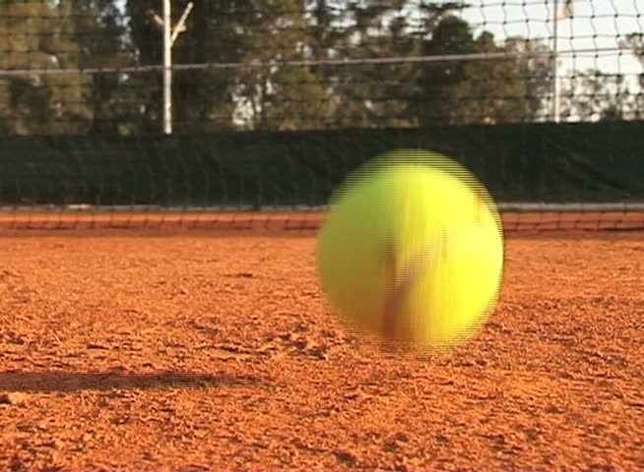

From the given condition. You find that
$$a\left(t\right)=-32ft/\sec^{2}$$
$$V_{0}=-64ft/sec$$
$$S_{0}=512ft$$

The distance is zero when the ball reaches the ground or hence the ball will reach the ground 4 after it is thrown.

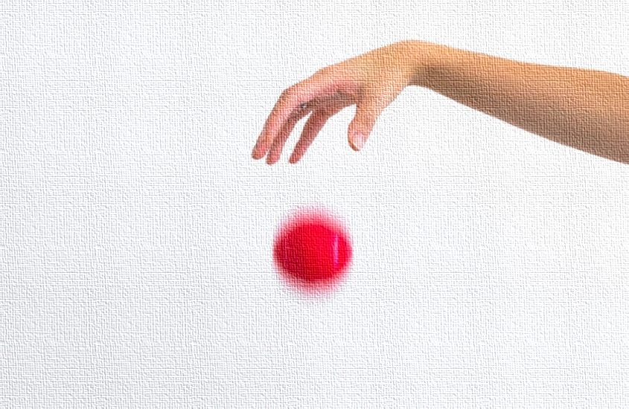
But you want the actual speed when the ball hits the ground and how you’re stock because however accurate your equipment is, it can’t tell you the exact speed the movement it hits the ground because no time passed in that last moment. But limits can give you that

$$V_{final}=\lim{time →\frac{distance}{time}}$$

As we measure the time it takes as we get closer to the ground, the time approaches (and so does the distance.)

You drop a ball 40 feet high from the top story of your house. You uses stop watch to determine how long will it takes to hit the ground. Let’s say it takes about 2.5 seconds but you want the coverage velocity of a ball so uses this formula.

$$V_{\begin{aligned}avg =\frac{distance}{time} = \\ \frac{40}{2.5}=16 feet per second\end{aligned}}$$

You want to know the ball’s velocity just be for it hits the ground. So you uses a motion capturing equipment and drop the ball again. You see that it has a continuous time display as well as the height of the ball at a given time.

So you just look at the time stamps the ball is 1 foot off the ground and when the ball hits the ground you subtract these time stamps to get the time it took to drop the last foot. Although this speed is to its speed when it hits the ground. It’s still less the real value because it was accelerating that last foot.

The Torque Balance
Three masses are attached to a uniform meter stick, as shown in Figure 12.9. The mass of the meter stick is 150.0 g and the masses to the left of the fulcrum are m₁ = 50.0 g and m₂ = 75.0 g. Find the mass m3 that balances the system when it is attached at the right end of the stick, and the normal reaction force at the fulcrum when the system is balanced.

Solution
They begin by finding the lever arms of the five forces acting on the stick:
$$r_{1}=30.0 cm+40.0cm=70.0cm$$
$$r_{2}=40.0cm$$
$$r=50.0cm-30.0cm=20.0cm$$
$$r_{s}=0.0 cm(because Fs is attached at the pivot)$$
$$r_{3}=30.0cm$$
Now they can find the five torques with respect to the chosen pivot:
$$T_{1}=+r_{1}w_{1}\sin{90°=+r_{1}m_{1}g}$$
$$T_{2}=+r_{2}w_{2}\sin{90°=+r_{2}m_{2}g}$$
$$T=+rw\sin{90°=+rmg}$$
$$TS=r_{s}F_{s}\sin{θs}=0$$
$$T_{3}=-r_{3}w_{3}\sin{90°=-r_{3}m_{3}g}$$
The second equilibrium condition (equation for the torques) for the meter stick is
$$T_{1}+T_{2}+T_{s}+T_{3}=0$$
When substituting torque values into this equation, we can omit the torques giving zero contributions. In this way the second equilibrium condition is
$$+r_{1}m_{1}g+r_{2}m_{2}g+rmg-r_{3}m_{3}g$$

Selecting the +y-direction to be parallel to F⃗ SF→S, the first equilibrium condition for the stick is
$$-w_{1}-w_{2}-w+F_{S}-w_{3}=0$$
Substituting the forces, the first equilibrium condition becomes
$$-m_{1}g-m_{2}g-mg+F_{S}-m_{3}g=0$$

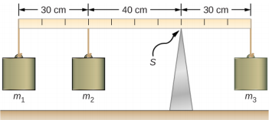

In a torque balance, a horizontal beam is supported at a fulcrum and masses are attached to both sides of the fulcrum. The system is in static equilibrium when the beam remains level.
For the arrangement shown in the figure, we identify the following five forces acting on the meter stick:
- w₁ = m₁g is the weight of mass m₁;
- w₂ = m₂g is the weight of mass m₂;
- w = mg is the weight of the entire meter stick;
- w₃ = m₃g is the weight of unknown mass m₃;
- F_{S} is the normal reaction force at the support point S.

They solve these equations simultaneously for the unknown values m₃ and F_{S}. In this equation, they cancel the g factor and rearrange the terms to obtain.
$$r_{3}m_{3}=r_{1}m_{1}+r_{2}m_{2}+rm$$
To obtain m₃ we divide both sides by r₃, so we have
$$m_{3}=\frac{r_{1}}{r_{3}}m_{1}+\frac{r_{2}}{r_{3}}m_{2}+\frac{r}{r_{3}}m$$

$$=\frac{70}{30}\left(50.0g\right)+\frac{40}{30}\left(75.0g\right)+\frac{20}{30}\left(150.0g\right)=315.0(\frac{2}{3})$$
To find the normal reaction force, we rearrange the terms in Equation 12.18, converting grams to kilograms:
$$F_{s=\left(m_{1}+m_{2}+m+m_{3}\right)g}$$
$$=(50.0+75.0+150.0+316.7)×({10}^{-3}kg)×(9.8 m/s^{2}$$

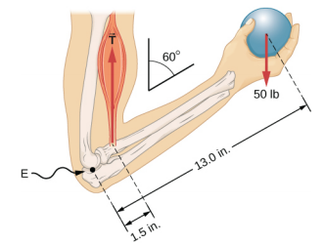
A weightlifter is holding a 50.0-lb weight (equivalent to 222.4 N) with his forearm, as shown in Figure 12.11. His forearm is positioned at ββ = 60° with respect to his upper arm. The forearm is supported by a contraction of the biceps muscle, which causes a torque around the elbow. Assuming that the tension in the biceps acts along the vertical direction given by gravity, what tension must the muscle exert to hold the forearm at the position shown? What is the force on the elbow joint? Assume that the forearm’s weight is negligible. Give your final answers in SI units.

Free-body diagram for the forearm for the equivalent solution. The pivot is located at point E(elbow).

We see from the free-body diagram that the x-component of the net force satisfies the equation
+$F_{x}$+$T_{x}$−$w_{x}$=0
and the y-component of the net force satisfies and the y-component of the net force satisfies
+$F_{y}$+$T_{y}$−$w_{y}$=0
Equation 12.21 and Equation 12.22 are two equations of the first equilibrium condition (for forces). Next, we read from the free-body diagram that the net torque along the axis of rotation is
+$r_{T}$+$T_{y}$−$r_{w}w_{y}=$0

Equation 12.23 is the second equilibrium condition (for torques) for the forearm. The free- do not need to convert inches into SI units, because as long as these units are consistent in Equation 12.23, they cancel out. Using the free-body diagram again, we find the magnitudes of the component forces:
$F_{x}$= F cosβ = F cos60$°$ = $\frac{F}{2}$
$T_{x}$= T cosβ = T cos60$°$= $\frac{T}{2}$
$W_{x}$= W cosβ =W cos60$°$= $\frac{W}{2}$,
We substitute these magnitudes into Equation 12.21, Equation 12.22, and Equation 12.23 to obtain, respectively,
$$\frac{F}{2}+\frac{T}{2}-\frac{w}{2}=0$$
$$\frac{F\sqrt{3}}{2}+\frac{T\sqrt{3}}{2}-\frac{w\sqrt{3}}{2}=0$$
$$\frac{r_{T}T\sqrt{3}}{2}-\frac{r_{w}W\sqrt{3}}{2}=0$$

When we simplify these equations, we see that we are left with only two independent equations for the two unknown force magnitudes, F and T, because Equation 12.21 for the x-component is equivalent to Equation 12.22 for the y-component. In this way, we obtain the first equilibrium condition for forces
F+T−w=0
and the second equilibrium condition for torques
$$r_{T}T-r_{w}W=0$$
The magnitude of tension in the muscle is obtained by solving Equation 12.25:
$$T=\frac{r_{w}}{r_{T}}w=frac13.01.5\left(50 lb\right)=433\frac{1}{3}lb$$
$$≅433.3 lb.$$
The force at the elbow is obtained by solving Equation 12.24:
F=w−T=50.0lb−433.3lb=−383.3lb
The negative sign in the equation tells us that the actual force at the elbow is antiparallel to the working direction adopted for drawing the free-body diagram. In the final answer, we convert the forces into SI units of force. The answer is
$$F=383.3 lb=383.3\left(4.448 N\right)=1705 N$$
Downward
$$T=433.3 lb=433.3\left(4.448 N\right)=1927 N$$

Upward

A Ladder Resting Against a Wall
A uniform ladder is L = 5.0 m long and weighs 400.0 N. The ladder rests against a slippery vertical wall, as shown in Figure 12.14. The inclination angle between the ladder and the rough floor is ββ = 53°. Find the reaction forces from the floor and from the wall on the ladder and the coefficient of static friction μsμs at the interface of the ladder with the floor that prevents the ladder from slipping.

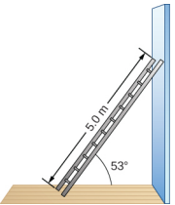

Figure 12.2.6 A 5.0-m-long ladder rests against a frictionless wall.
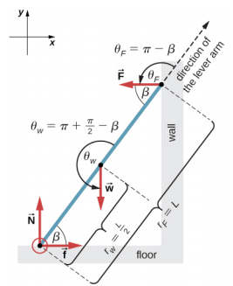
Figure 12.2.7: Free-body diagram for a ladder resting against a frictionless wall.

Solution

From the free-body diagram, the net force in the x-direction is

$$+f-F=0$$
the net force in the y-direction is
$$+N-w=0$$
and the net torque along the rotation axis at the pivot point is
$$T_{w}+T_{F}=0$$

Significance
This result is independent of the length of the ladder because L is canceled in the second equilibrium condition, Equation 12.31. No matter how long or short the ladder is, as long as its weight is 400 N and the angle with the floor is 53°, our results hold. But the ladder will slip if the net torque becomes negative in Equation 12.31. This happens for some angles when the coefficient of static friction is not great enough to prevent the ladder from slipping.
For the situation described in Example 12.5, determine the values of the coefficient μsμs of static friction for which the ladder starts slipping, given that β is the angle that the ladder makes with the floor.

We should emphasize here two general observations of practical use. First, notice that when we choose a pivot point, there is no expectation that the system will actually pivot around the chosen point. The ladder in this example is not rotating at all but firmly stands on the floor; nonetheless, its contact point with the floor is a good choice for the pivot. Second, notice when we use Equation 12.10 for the computation of individual torques, we do not need to resolve the forces into their normal and parallel components with respect to the direction of the lever arm, and we do not need to consider a sense of the torque. As long as the angle in Equation 12.10 is correctly identified—with the help of a free-body diagram—as the angle measured counterclockwise from the direction of the lever arm to the direction of the force vector, Equation 12.10 gives both the magnitude and the sense of the torque. This is because torque is the vector product of the lever-arm vector crossed with the force vector, and Equation 12.10 expresses the rectangular component of this vector product along the axis of rotation.
where τwτw is the torque of the weight w and τFτF is the torque of the reaction F. From the free-body diagram, we identify that the lever arm of the reaction at the wall is r_{F} = L = 5.0 m and the lever arm of the weight is r_{w} = L2L2 = 2.5 m. With the help of the free-body diagram, we identify the angles to be used in for torques: θFθF = 180° − ββ for the torque from the reaction force with the wall, and θwθw = 180° + (90° − ββ) for the torque due to the weight. Now we are ready to use to compute torques:
$$T_{w=r_{w}W\sin{θ_{w}=r_{w}W\sin\left(180°+90°-β\right)}}$$
$$=-\frac{L}{2}w\sin\left(90°-β\right)=-\frac{L}{2}w\cos{β}$$
$${tau}_{F}=rF\sin{θ_{F}=rF\sin\left(180-β\right)}$$
$$=LF\sin{β}$$
The net force on the ladder at the contact point with the floor is the vector sum of the normal reaction from the floor and the static friction forces:
$${\vec{F}}_{floor}=\vec{f}+\vec{N}=(150.7 N)(-\hat{i})$$
$$+\left(400.0 N\right)\left( \right)\left(-\hat{j}\right)=\left(150.7\hat{i}+400.0\hat{j}\right)N.$$
Its magnitude is
$${\vec{F}}_{floor}=\sqrt{f^{2}+N^{2}}=\sqrt{{150.7}^{2}+{400.0}^{2}}N$$
$$=427.4 N$$
and its direction is
$$φ=\tan^{-1}\left(\frac{N}{f}\right)=\tan^{-1}\left(\frac{400.0}{150.7}\right)=69.3°$$
Above the floor.

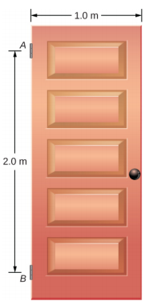
Figure 12.2.812.2.8: A 400-N swinging vertical door is supported by two hinges attached at points A and B.
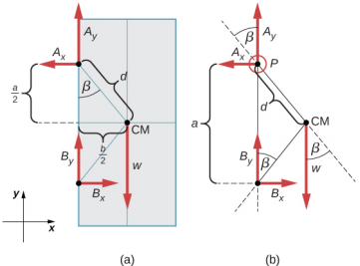
Figure 12.2.912.2.9: (a) Geometry and (b) free-body diagram for the door.

Forces on Door Hinges
A swinging door that weighs w = 400.0 N is supported by hinges A and B so that the door can swing about a vertical axis passing through the hinges Figure 12.16. The door has a width of b = 1.00 m, and the door slab has a uniform mass density. The hinges are placed symmetrically at the door’s edge in such a way that the door’s weight is evenly distributed between them. The hinges are separated by distance a = 2.00 m. Find the forces on the hinges when the door rests half-open

The forces on the hinges are found from Newton’s third law as
on the upper hinge:
$${\vec{F}}_{B on door A}= 100.0 N \hat{i }-200.0N \hat{J}$$
on the lower hinge:
$${\vec{F}}_{B on doorB}= -100.0 N \hat{i }-200.0N \hat{J}$$
We use the free-body diagram to find all the terms in this equation:
$$T_{w}=dw\sin\left(-β\right)=-dw\sin{β=-dw\frac{\frac{b}{2}}{d}=-w\frac{b}{2}}$$
$$T_{Bx}=aB_{x}\sin{90°=+aB_{x}}$$
$$T_{By=aB_{y}\sin{180°=0}}$$
In evaluating sin ββ, we use the geometry of the triangle shown in part (a) of the figure. Now we substitute these torques into Equation 12.32 and compute B_{x}:
pivot at P:
$$-w\frac{b}{2}+aB_{x}=0⟹B_{x}=w\frac{b}{2a}=(400.0 N)\frac{1}{2.2}$$
$$=100.0 N$$

Solution
From the free-body diagram for the door we have the first equilibrium condition for forces:
in the x-direction,
$$-A_{x}+B_{y}=0⟹A_{x}+B_{x}$$
in y-direction,
$$+A_{y}+B_{y}-w=0$$
$$\frac{w}{2}=\frac{400.0 N}{2}$$
We select the pivot at point P (upper hinge, per the free-body diagram) and write the second equilibrium condition for torques in rotation about point P: pivot at P:
$$T_{w}+T_{Bx}+T_{By}=0$$

A 50-kg person stands 1.5 m away from one end of a uniform 6.0-m-long scaffold of mass 70.0 kg. Find the tensions in the two vertical ropes supporting the scaffold.
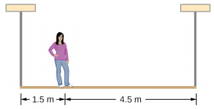

.

A 400.0-N sign hangs from the end of a uniform strut. The strut is 4.0 m long and weighs 600.0 N. The strut is supported by a hinge at the wall and by a cable whose other end is tied to the wall at a point 3.0 m above the left end of the strut. Find the tension in the supporting cable and the force of the hinge on the strut.


