_{Step 1}
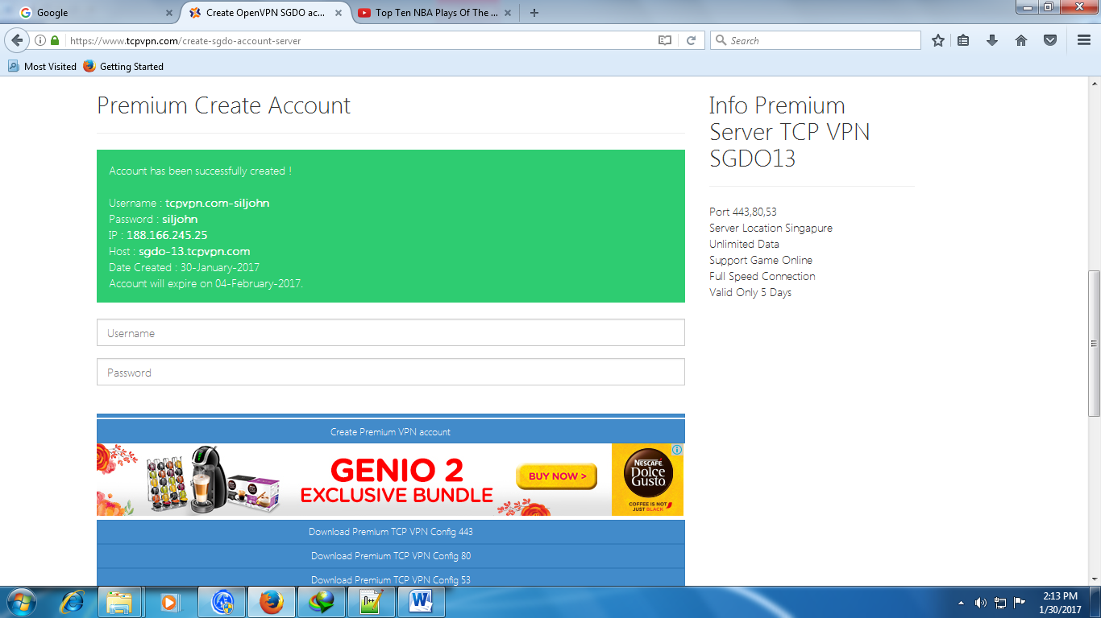
https://www.tcpvpn.com/
Open
X-SGDO
Create Account
Find Open Server

_{Step 2}
squid-proxy
Http
80, 81, 8080, 8000 and 3128

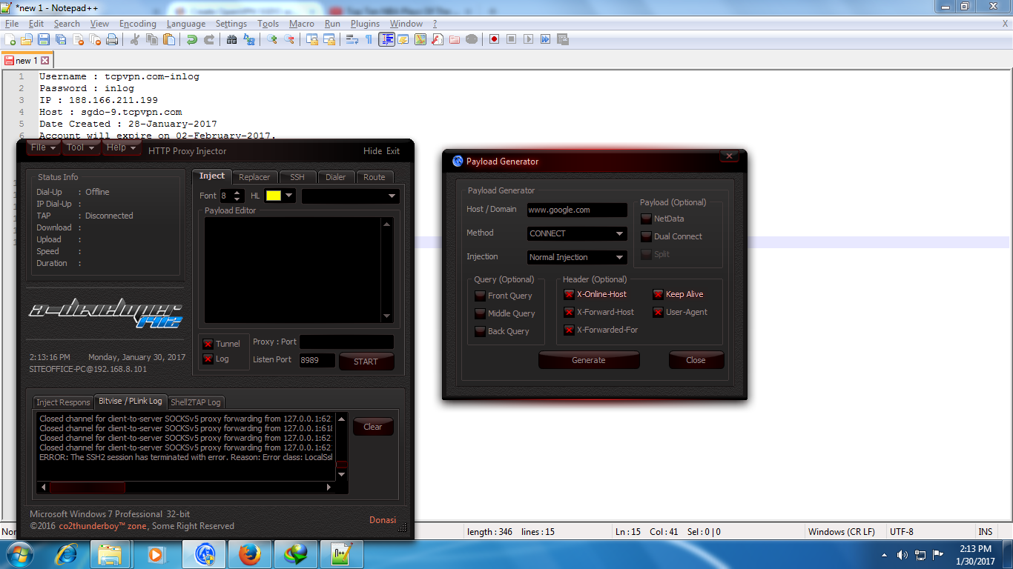
_{Step 3}

_{Step 3}
Tools
Payload Generator
Host/Domain: www.google.com
Method: Connect
Injection: Normal injection

Header(Optional)
Check all 5 box

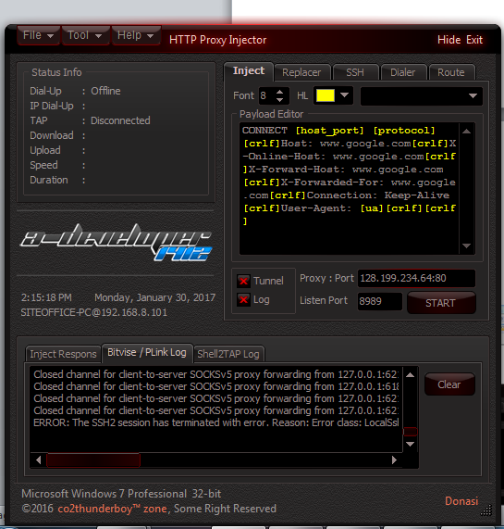
Proxy: Port :128.199.234.64: exaple
Select
80
3128
8000
8080
_{Step 4}

_{Step 5}
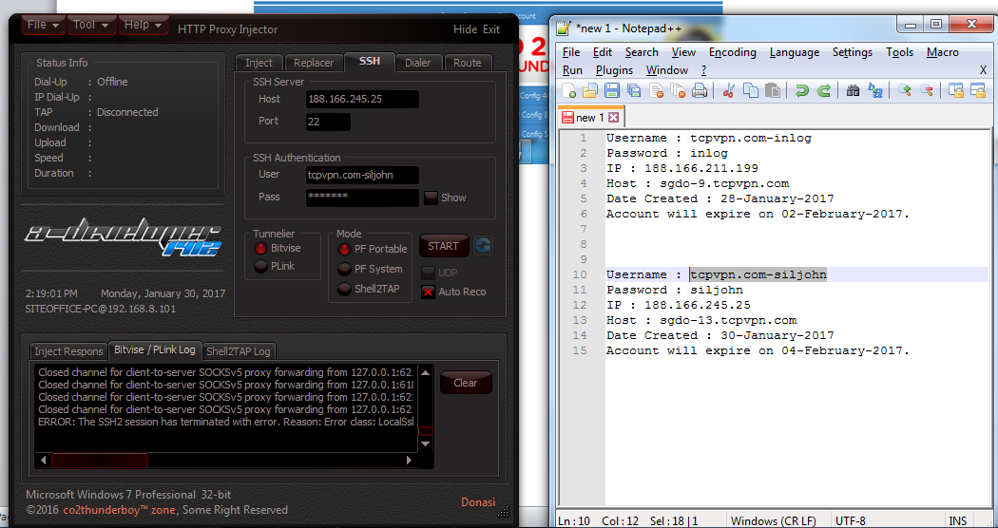

Remember the
Bitvise
PF Portable
Auto Reco
SSH:
Host: 188.166.245.25 depend in your account created
Username: depend in your username
Password: depend in your password

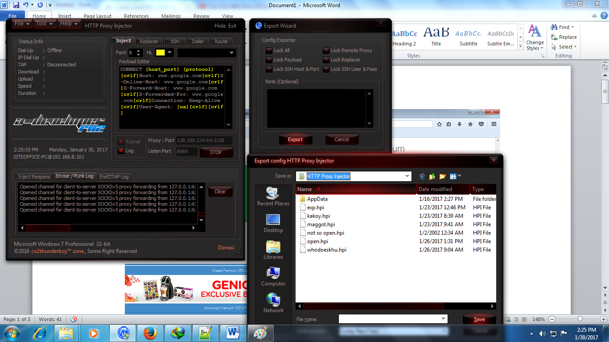
Step 6
Remember the
File
Export
Save File Name

