LAB – Solutions & Concentration PhET
https://phet.colorado.edu/sims/html/concentration/latest/concentration_en.html
- Saturated - Thoroughly soaked
- Supersaturated - Increase the concentration of a solution beyond saturation point
- Solubility - The ability to be dissolved
- Concentration - amount of a substance per defined space
- Solute - Substance dissolved in another substance
- Solvent - Substance that dissolves a solute
- Molarity - The number of moles of the substance per liter of liquid, the number of moles divided by the volume of the solution it’s in
- Dilute - Reducing the concentration of a solute in a solution
- Molar - Molar concentration has the units mol/L or M
- Insoluble - Inability to dissolve
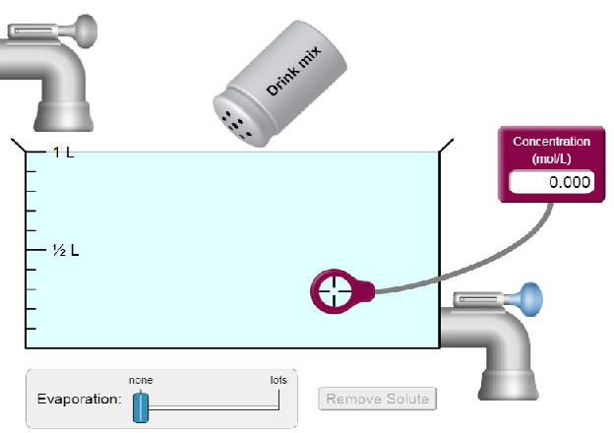
LAB - Part 1: Concentration Calculations Using Molarity Formula
Procedure:
- For Trial 1: Fill up the tank to 1 L, choose Solute: Drink Mix(solid), drag purple concentration meter into the tank as shown:
- Shake the shaker to add solute to the water until you have an approx. concentration = 2 mol/L. Record the exact “Concentration of Soln’” in Data Table 1.
- Reduce the volume of water to approx. 0.50 L by draining half the tank. Without recording anything, notice any effect on the concentration and answer Question 1.
- Click to begin next trial.
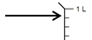
- For Trial 2(etc), Choose Cobalt (II) Nitrate (solid) & record its chemical formula and molar mass in Data Table 1. Fill your tank to the 9th mark as shown. Note the tank’s volume is graduated by 0.1 L marks, so the volumes are written to the hundredths decimal place. Again, add solute until your concentration is approx. 2.0 mol/L and record the exact concentration in your table. If the solution reaches saturation before you are able to reach this concentration, write the word “SATURATED” in the concentration column and mark through the rest of that row on the Analysis Table – We will discuss saturation in Part 2. Click to begin next trial
- Repeat #5 for the other solid solutes, each time use 0.1 L less water (one mark down)
LAB - Part 1: Analysis
- For the unsaturated trials only, use the molarity formula:  to find the moles of solute added in each trial, fill in Analysis Table 1. Note – the unit for Molarity is mol/L, but is often called “Molar,” abbreviated with a capital “M.” Show work for Cobalt(II) Nitrate only below:
1.994 = x/.9 x = 1.795 mol
- For the unsaturated trials only, convert the mole of solute to grams for each trial and fill in Analysis Table 1. Recall: 1 mol = Molar Mass(g). Show work for Cobalt (II) Nitrate only below:
1.795 mol Co(NO₃)₂ /1 * 182.947 g/1 mol = 328.39 g
LAB - Part 1: Data & Analysis
 | DATA TABLE 1 |  |  |  |  | ANALYSIS TABLE 1
Solute |  | Chemical Formula | Molar Mass (g/mol) | Volume of Water (L) | Concentration of Soln’ (mol/L or M) | Moles of Solute  (mol) | Grams of Solute (g)
 |  | UNKNOWN | UNKNOWN | 1.00 | 2.04 | OMIT | UNKNOWN
 |  | Co(NO₃)₂ | 182.947 | 0.90 | 1.994 | 1.795 | 328.39
 |  | CoCl₂ | 129.839 | 0.80 | 2.001 | 2.501 | 324.727
 |  | K₂Cr₂O₇ | 294.188 | 0.70 | SATURATED @.51 | ------ | ------
 |  | K₂CrO₄ | 194.192 | 0.60 | 2.018 | 3.363 | 653.068
 |  | NiCl₂ | 129.599 | 0.50 | 2.003 | 4.006 | 519.174
 |  | CuSO₄ | 159.612 | 0.40 | SATURATED @1.38 | ------ | ------
 |  | KMnO₄ | 158.036 | 0.30 | SATURATED @.48 | ------ | ------

LAB - Part 1: Conclusion Questions
Explain/answer the following questions using complete sentences.

- Without adding any new solute, did draining some solution dilute the solution?
No, the concentration stayed the same
- Which solute required the most mass to reach the 2 mol/L concentration? Least mass?
Potassium Chromate; Cobalt Chloride
- Which solutes saturated before reaching a concentration of 2 mol/L?
Potassium Dichromate, Copper Sulfate, and Potassium Permanganate
- As you completed the trials, why should it take less & less mass to reach the concentration of 2.0 mol/L?
Because each trial is using less and less water

LAB - Part 2: Saturation

Procedure:
- Drain the tank. Choose the dropper solution for Cobalt (II) Nitrate  and fill the tank to 0.50 L (L). The solution is almost saturated. Add a little bit more solid solute with the shaker  until you reach the saturation for Cobalt (II) Nitrate. In Data Table 2, record the “Concentration at Saturation Point (mol/L or M)”.
- Shake in extra solute until you see the solid particles settling on the bottom and answer Question #1.
- Click and repeat with each solute, skipping the Drink Mix using 0.50 L (1/2 L) every time.

LAB - Part 2: Analysis
- Calculate the moles of solute required to saturate the solution using the molarity formula and record your result in Analysis Table 2. Show work for Cobalt(II) Nitrate only below:
molarity = moles of solute/volume of solution in liters
5.64 = mols/.5
mols = 2.82
- Calculate the grams of solute required to saturate the solution using the molar mass and record your results in Analysis Table 2. Show work for Cobalt (II) Nitrate below.
2.82 mol Co(NO₃)₂/1 * 182.947 g/mol = 516 g
DATA TABLE 2 |  | ANALYSIS TABLE 2
Solute | Concentration at Saturation Point  (mol/L or M) | Moles required to saturate solution (mol) | Grams required to saturate solution (g)
 | 5.64 | 2.82 | 516
 | 4.33 | 2.165 | 281
 | 0.51 | 0.255 | 75
 | 3.35 | 1.675 | 325
 | 5.21 | 2.605 | 338
 | 1.38 | 0.69 | 110
 | 0.48 | 0.24 | 38

LAB - Part 2: Conclusion Questions
Explain/answer the following questions using complete sentences.

- Once the solution saturated, the added solid solute does not dissociate. What does the excess do?
Sit at the bottom of the container.
- Using 0.50 L of solution each time, does the solubility of the solutes seem similar?
No, the saturations are still very different.
- How could you “supersaturate” these solutions, exceeding the amount of dissolved solute possible for a given volume of solvent by preventing formula units from precipitating into crystals?
Heat, mixing/agitating the mixture, etc.
LAB - Part 3: HONORS ONLY: Mass Percent & Graphing Mass Vs. Volume
Procedure:
- Click . Begin by creating a saturated 0.10L solution of Cobalt (II) Nitrate. Record the minimum concentration to saturate this volume in Data Table 3.
- Add more solution to create a 0.20 L volume and record concentration. Continue up to a 1.00L volume.
LAB - Part 3: Analysis
- Calculate the moles of solute required to saturate the solution using the molarity formula and record your result in Analysis Table 3. Only show work for 0.10 L solution below:
molarity = mol of solute/vol in L
5.64 = mol/.1
mol = 0.564
- Calculate the grams of solute required to saturate the solution using the molar mass and record your results in Analysis Table 3. Only show work for 0.10 L solution below:
.564 mol/1 * 182.947 g/mol = 103.182 g
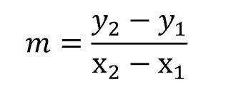
- On the Mass of Solute Vs. Volume of Solution, plot data points & make a line of best fit. Show calculation of the slope of this line using: (This result is called Mass/Volume %)

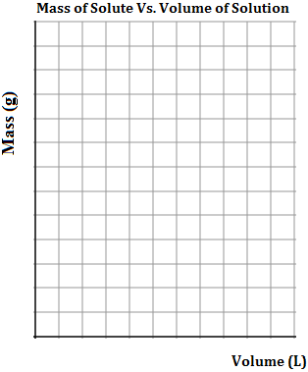
Slope = 1031.82
DATA TABLE 3 |  | ANALYSIS TABLE 3
Volume of Solution | Concentration at Saturation Point  (mol/L or M) | Moles required to saturate solution (mol) | Grams required to saturate solution (g)
0.10 | 5.64 | 0.564 | 103.182
0.20 | 5.64 | 1.128 | 206.364
0.30 | 5.64 | 1.692 | 309.546
0.40 | 5.64 | 2.256 | 412.728
0.50 | 5.64 | 2.82 | 515.911
0.60 | 5.64 | 3.384 | 619.093
0.70 | 5.64 | 3.948 | 722.275
0.80 | 5.64 | 4.512 | 825.457
0.90 | 5.64 | 5.076 | 928.639
1.00 | 5.64 | 5.64 | 1031.821
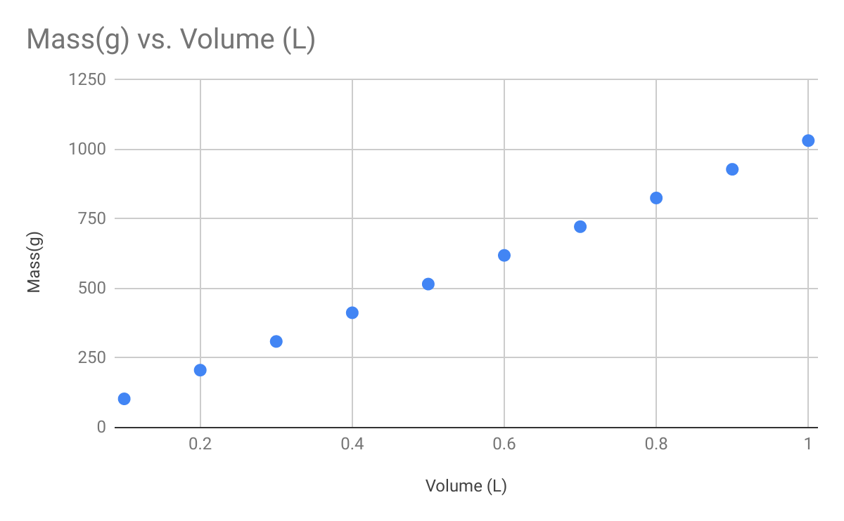
LAB - Part 3: Questions
Explain/answer the following questions using complete sentences.
- The mass of a solute versus the volume of a solution is known as mass/volume percent. It is a unit for concentration (g/L x 100%) often used in medicine, particularly with IV bags. If the mass percent of the saline is 0.9%, how many grams of “salt” in a 1 L saline IV?
Show Work:
g/L = .9
g/1 = .9
g = .9

