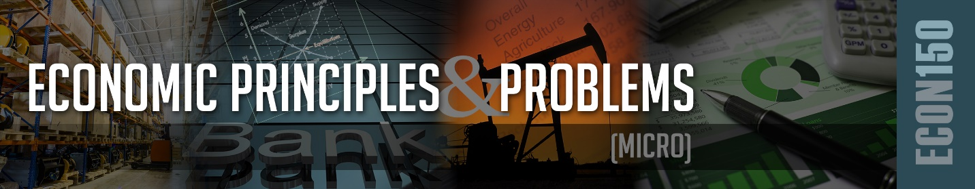

CHAPTER 1 READING OUTLINE

Answer the following questions in your own words and submit the completed file on I-Learn.

- Since we have unlimited needs and wants but only limited resources, we face trade-offs with each decision. Explain how a rational individual would compare the marginal benefit to the marginal cost when making decisions.
This is something I face every time I go to purchase something. For example, I decided to purchase a tablet for school so I can do readings when I have downtime at work. I could save money on buying an older model tablet, but if it’s too old support will stop for it and I won’t get updates without rooting it. Yet if I buy one that is top of the line and just came out support will last much longer and will have better features and could last much longer to where I don’t need another one for 3 years verses an older one at 2 years.
- Explain why the other-things-equal assumption or ceteris paribus is important when analyzing relationships.
It is extremely important because people like me can get distracted by some fascinating variable that might not have anything to do with when you are analyzing the relationship of one item’s price to sales amount. As it helps you focus on the one product (in this case) you can get an understanding on how to increase sales for that product alone as if it was the only one.

- Differentiate between micro- and macroeconomics.
Microeconomics focuses on the finer details such as decision making of customers, households, employers, etc. They focus on a specific product and what it takes to produce it and its relationship of production to market.
Macroeconomics focuses on everything in general such as how land and resources are used, inflation and deflation in a nation, economics of governments, etc. instead of looking at one little product they look over how everything is flowing within the world of economics.

- Differentiate between positive and normative economics.
Positive economics is factual or cause-and-effect relationships and tries to establish a more scientific approach. Whereas normative economics is based on “value” judgments about what the economy should be like (or specific policy should be acted on) and establishes a more desirable outcome for the economy or policy.
- Explain a budget line and how to construct it.
A budget line is a graph which shows what two items can be purchased in combinations given an amount of income that can be spent. To construct it you first figure out how much each product costs then you start one product off at purchasing none and the other as many as your budget allows. You then go through the process of calculating as such income = A + B where product A is the price multiplied by how many you are purchasing and the same goes for B.
- Identify types of economic resources.
Land, labor, capital, and entrepreneurs are all economic resources.
- Explain what the production possibilities curve (PPC) demonstrates and the assumptions to be on the curve.
  - Explain what will shift the PPC out and in
Increase in your resource supplies or technological advances will push your PPC outwards. But if you have a high amount of unemployment and cannot get you’re your full PPC potential then your curve might shift in.
  - Explain what will move you away from or toward the PPC.
Unemployment will move you away or toward the PPC if you are functioning within the PPC as the PPC is everything working to its full potential in your current economic possibility.
  - Explain how a society’s decision to produce capital (i.e., machinery) or consumer goods will impact future growth.
Depending on their current economic state it could boost their future growth or have no effect at all based on their current state and its future potential. If the societies unemployment rate increases, then the decision will have not benefited them at all.

Math Review & Appendix

- Explain a direct and inverse relationship between two variables and give an example of each.
A direct relationship is when two variables increase and decrease together. Such as the relationship of a price increase or decrease to the quantity of goods increase and decreasing.
An inverse relationship is the opposite where when variable A increases then variable B decreases and vice versa. Such is the case for the Apple iPhone 7 where there is more demand for product supplied.

- Given the linear equation: Consumption = 100 + 0.25 (Income)
- Identify the dependent and independent variable?
The income is the independent variable and the consumption is the dependent.
- How much is consumption when income is zero?
100
- If one’s income was $2,000, what is their estimated consumption?
Estimated consumption would be 600.

- Given a demand curve: P = 120 – 2Q and a supply curve of P = 20 + 3Q, where P is the price of the good and Q is the quantity. Set the two equations equal and solve for the equilibrium P and Q.

P = 80 & Q = 20 The equilibrium point is 80 after both are calculated

- Discuss the advantages and disadvantages of the major that you have chosen and the tradeoffs associated with selecting that major.
The advantage is that I can continue to work where I am without having to take a pay cut once I graduate. Verses starting a new career path where I would have to start at the bottom of the food chain.
Although the disadvantage is that I might get stuck with more responsibilities on my plate with a degree and not make as much as I should.
The tradeoff is that I would be able to change professions if I want and when I need to making life easier on my family and I. Which would also allow me to live a more normal life.

- Give one example of how the principles in this chapter currently impact your life or relate to your chosen career.
I know I am a novice at this subject as I have been studying computers most my life. Although with what I have been able to learn in this chapter is that I use a lot of these principals already in my life and so learning of it will better my decision making.

