
Philippine Normal University
The National Center for Teacher Education
Technology and Livelihood Education Hub
South Luzon Campus
Lopez, Quezon

STLE-24:
PRINCIPLES AND METHODS IN TEACHING INDUSTRIAL ARTS
(LESSON PLAN IN PLUMBING)
GRADE 7

CONTENT STANDARD  (REQUIRED SKILLS) | - Identifying hazards/risks and control
PERFORMANCE STANDARD  (PERFORMANCE CRITERIA) | - Hazards/risks in the workplace and their corresponding indicators are identified to minimize or eliminate risk/exposure to co-workers, workplace and environment in accordance with organization’s procedures
LEARNING OUTCOME  (ELEMENT) | - Identify hazards and risks
LEARNING COMPETENCIES | Identify the different hazards or risk and control
LESSON OBJECTIVES | - Identify hazards and risks;  - Evaluate risks and hazards; and  - Control hazards and risks.
LESSON TITLE | PRACTICE OCCUPATIONAL HEALTH AND SAFETY PROCEDURES
REFERENCES | Training Regulations in Plumbing NC II Plumbing Construction Sector  TECHNICAL EDUCATION AND SKILLS DEVELOPMENT AUTHORITY  East Service Road, South Superhighway, Taguig City, Metro Manila
MATERIALS NEEDED | Picture, Manila Paper, Powerpoint, Cartolina
VALUES TO BE INTEGRATED | Holistic Health
ESSENTIAL QUESTIONS | Why is it important to practice occupational health and safety procedure?
PRELIMINARIES | - Cleanliness  - Orderliness  - Prayer  - Attendance
REVIEW | The teacher will ask the students about the different tools and materials in plumbing and will explain its uses.  Time Allotted: 3 minutes
MOTIVATION | - The class will be divided into 2 groups.  - The two groups will be given a pipe puzzle.  - Using a tape they must connect each pipe to each other for the water to be flow and put it in the manila paper and place in the blackboard.  - The group who will finish the task first will be the winner and will receive prizes.  Processing questions:  - What have you observed about the activity?  - What is the purpose of joining or fixing of broken parts or pieces of an object?  Time Alloted: 5 minutes
ACTIVITY | - The students will be divided into four groups.  - The teacher will give a one picture in each group.  - Using the manila paper and a marker, the group will write their opinions about the importance of the picture that they will see.  Time Allotted: 5 minutes
ANALYSIS | The students will answer the following questions:  - Are the pictures in the activity are familiar?  - What have you observed about the pictures during the activity?  - Where do you commonly see the things shown in the pictures?  - What are the uses of the things shown in the picture?
ABSTRACTION | DISCUSSION  HAZARD, RISK AND EXPOSURE IN THE WORKPLACE  Plumbing works covers with a lot of activities to be done in the different workplace. Workplace hazard is a major cause of accident, injury, or harm to a worker who performs such task. These hazards should be the major concern of all who are involved in a certain job or work. It is important to distinguish hazard, risk and exposure when undertaking risk management.  Definition:  - Hazard is the potential for harm, or adverse effect on an employee’s health. Anything which may cause injury or ill health to anyone at or near a workplace is a hazard.  - Risk is the likelihood that a hazard will cause injury or ill health to anyone at or near a workplace. The level of risk increases with the severity of the hazard and the duration and frequency of exposure.  - Exposure occurs when a person comes into contact with a hazard.  - Accident is an event occurring unintentionally or by chance.  - Control means to direct or determine.  - Occupation is an activity in which one is engaged in.  - OHSP Occupational Health and Safety Procedures  - PPE Personal Protective Equipment  - Safety state of being out danger, uninjured, not involving risk  Types of Hazard  Hazards are classified into five different types. They are:  1. Physical - includes floors, stairs, work platforms, steps, ladders, fire, falling objects, slippery surfaces, manual handling (lifting, pushing, pulling), excessively loud and prolonged noise, vibration, heat and cold, radiation, poor lighting, ventilation, air quality  2. Mechanical and/or electrical - includes electricity, machinery, equipment, pressure vessels, dangerous goods, fork lifts, cranes, hoists  3. Chemical - includes chemical substances such as acids or poisons and those that could lead to fire or explosion, like pesticides, herbicides, cleaning agents, dusts and fumes from various processes such as welding  4. Biological - includes bacteria, viruses, mold, mildew, insects, vermin, animals  5. Psychosocial environment - includes workplace stressors arising from a variety of sources.  WORKING CONDITIONS THAT CAN PRODUCE HAZARDS  1. Falling objects  2. Objects that can puncture skin  3. Objects that could roll over worker’s feet  4. Toxic chemicals  5. Heat  6. Harmful Dust  7. Radiation  Personal Protective Equipment (PPE)  Here are the types of Personal Protective Equipment (PPE) use for safety  purposes:  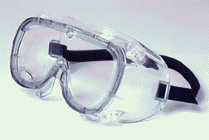  A. Face protection  Goggles and face protection must be used  when workers are at risk from flying particles, liquid  chemicals, acids or caustic liquids and chemical gases.  Various goggles for face protection must meet certain  design criteria for safety.  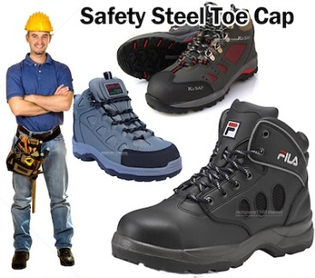  B. Foot Protection  Safety shoes with impact protection are used in work areas  where heavy objects or tools could be accidentally dropped on  the feet. Safety shoes with puncture protection are required  when working around nails, wire tacks, scrap metals and other  objects that could fierce the feet.  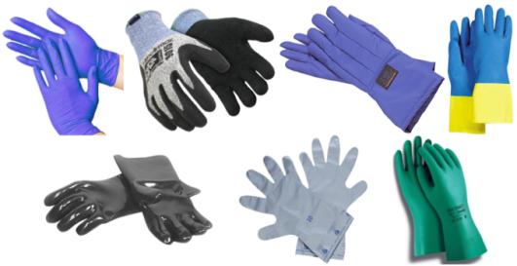  C. Hand Protection  Gloves are required to protect the hands of workers from cuts,  scrapes, punctures, burns, chemical absorption, and exhaust  temperatures. It is crucial that the type of glove being used is  the right one for the job.  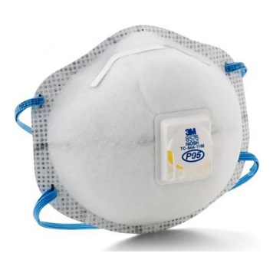  D. Hearing Protection  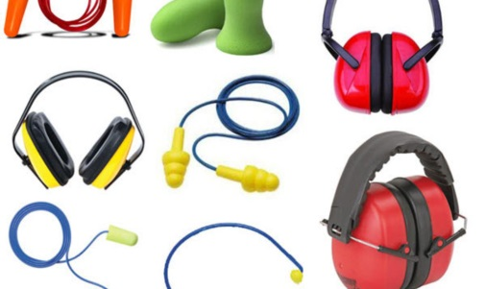  Appropriate ear muffs or ear plugs must be made available as a last resort if it is not possible to make the workplace less noisy. The requirement is a small part of the occupational noise exposure standard which requires employers to ensure that workers are exposed to less than 90 decibels of noise over an 8 hour period.  E. Respirators  Appropriate respirators must be worn as a last resort if it is not possible to ventilate the work area properly.  Occupation Health and Safety (OHS) Procedures for controlling hazards and risks.  1. Conduct a hazard assessment like;  - Survey workplace to identify hazards (put them in writing)  - Determine whether any hazard required Personal Protective Equipment.  - Pay attention to working conditions that can produce hazards  - Reassess hazards whenever necessary, especially when new equipment is installed  2. Select appropriate equipment;  Ensure that all Personal Protective  Equipment used is the right kind of equipment for the  job, and is maintained properly  Procedure in dealing with workplace, accidents, fire and Emergencies  PROCEDURES:  A. DEALING WITH ACCIDENTS  1. Keep calm, don’t panic and study the situation.  2. Report immediately to your teacher  3. Apply first aid to the victim while waiting for a nurse or a physician  4. Bring the patient to the nearest clinic or hospital  B. DEALING WITH FIRE  1. Do not panic, stay calm.  2. Call the attention of everybody.  3. Use your firefighting equipment to control extinguish the fire.  4. Call the office or the fire station  C. DEALING WITH EMERGENCIES  1. Stay calm and study the situation.  2. Call the attention of your teacher.  Time Allotted: 20 mins.
APPLICATION | Role Play  The students will divided into four groups, they will make a play showing a different hazards or accident and how to prevent or deal with it.  Time Allotted: 5 minutes
EVALUATION | PEN AND PAPER TEST  Multiple Choice.  DIRECTION: Write the letter of the correct answer before the number.  1. Your employer must conduct a hazard assessment in order to ___________.  a) avoid accident  b) promote accident  c) eliminate workers  2. OSH means _______________.  a) Occupational Service Healthy  b) Occupational Safe and Healthy  c) Occupational Safety and Health  3. Identifying hazards makes you_________________.  a) safe from working  b) comfortable while working  c) work efficient d) all of the above  4. Who should first know about the accident that happened in your shop?  a) principal  b) nurse  c) teacher  d) doctor  5. Accidents can be prevented ____________________.  a) through proper care and maintenance of tools and equipment  b) right attitude toward work  c) if you have a good knowledge about safety practices.  Enumeration  Give the five different types of hazards.  1.  2.  3.  4.  5.
ASSIGNMENT | Answer and explain the following.  What will you do when there is a:  - Fire  - Chemical exposure  - Injuries/Accidents

Prepared by:
Ingrid Jell L. Erandio
Pamela Camille Tombado
BTLE IV-B

