Final Laboratory Examination - Router, Switch and End Device Configuration & IP Addressing with VLSM

Addressing Table
Device | Interface | IP Address | Subnet Mask | Default Gateway
[[R1Name]] | G0/0 |  |  | N/A
MAIN | G0/1 |  |  | N/A
[[R1Name]] | S0/0/0 |  |  | N/A
[[R2Name]] | G0/0 |  |  | N/A
SAN_ISIDRO | G0/1 |  |  | N/A
[[R2Name]] | S0/0/0 |  |  | N/A
CCS | VLAN 1
CAFA | VLAN 1
CBA | VLAN 1
CET | VLAN 1
BSIT | NIC to f0/4
BFA | NIC to f0/4
BSBA | NIC to f0/4
BSME | NIC to f0/4

Objectives
- Configure hostnames and IP addresses on routers and switches using the command-line interface (CLI).
- Use Cisco IOS commands to specify or limit access to the device configurations.
- Use IOS commands to save the running configuration.
- Configure end devices with IP addresses.
- Use VLSM.
- Verify connectivity between devices using ping and tracert.

Instructions
Create the topology below.
1.Use 1941 router and 2960 switch.
2. Use appropriate media for connection.
3. Power off the router and choose HWIC-2T for the serial connection then turn on the router.

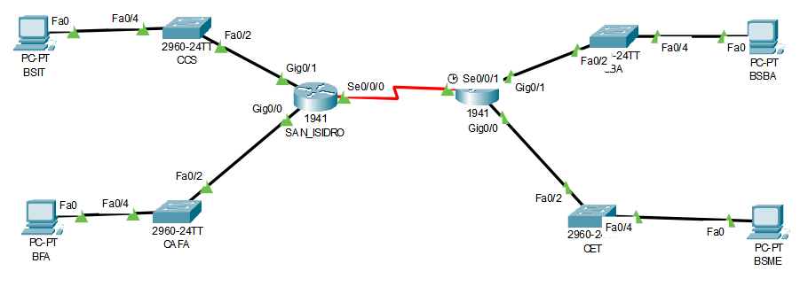

Topology Requirements
- Connect Devices using appropriate media to designated interfaces as showed in the addressing table.
- Connect SAN_ISIDRO and MAIN via DTE Serial Connection se0/0/0 to se0/0/1.
- Connect CCS and SAN_ISIDRO via Fast Ethernet 0/2 to Gigabit Ethernet 0/1
and CAFA and SAN_ISIDRO via Fast Ethernet 0/21to Gigabit Ethernet 0/0
- Connect CBA and MAIN via Fast Ethernet 0/2 to Gigabit Ethernet 0/1
and CET and MAIN via Fast Ethernet 0/21to Gigabit Ethernet 0/0
- Connect BSIT to CCS and BFA to CAFA (look at the addressing table)
- Connect BSBA to CBA and BSME to CTE (look at the addressing table)

VLSM Requirement
You have been given the network address 100.100.10.0/24. The host address requirements are:

LAN | Number of Addresses Required
CCS LAN | 126
CBA LAN | 25
CAFA LAN | 13
CET LAN | 28
WAN (San_ISIDRO to MAIN) | 2

- Document your design in a table such as the one below.
Subnet Description | Number of Hosts Needed | Network Address/CIDR | First Usable Host Address | Broadcast Address
blank | blank | blank | blank | blank
Blank | blank | blank | blank | blank
Blank | blank | blank | blank | blank
Blank | blank | blank | blank | blank
Blank | blank | blank | blank | blank
Configuration Requirements
Note: You will configure addressing on all devices and hosts in the network.
- Assign the first usable IP addresses in the appropriate subnets to SAN_ISIDRO for the two LAN links and the WAN link.
- Assign the first usable IP addresses in the appropriate subnets to MAIN for the two LANs links. Assign the last usable IP address for the WAN link.
- Assign the second usable IP addresses in the appropriate subnets to the switches.
- Assign the fifth usable IP addresses in the appropriate subnets to the hosts.

Router, Switch and Device Configuration
- Name the router and switches.
- Use tsu password for console and all vty lines.
- Use campus for enable password.
- Use college for secret password.
- Encrypt all clear text passwords.
- Configure the message-of-the-day (MOTD) with you full name ex. Gilbert Gonzales
- Configure addressing for all devices according to your created Addressing Table.
- In the global configuration of router SAN_ISIDRO and MAIN code
SAN_ISIDRO(config)# router eigrp 1
SAN_ISIDRO config)# network 100.100.10.0 255.255.255.0

MAIN(config)# router eigrp 1
MAIN(config)# network 100.100.10.0 255.255.255.0

- Save your configurations.

Test Connectivity
Verify connectivity between (make sure to test connectivity, paste a screenshot of all your ping and tracert)
- BSBA to BSIT
- BSIT to BSME
BSME to BFA
BFA to BSBA

Dare this Challenge to get additional 5 points in the Final Written Examination.
Configure IPv6 Addressing using the following
WAN 2001:DBB:ACAD:1::/64
CCS LAN 2001:DBB:ACAD:2::/64
CAFA LAN 2001:DBB:ACAD:3::/64
CBA LAN 2001:DBB:ACAD:4::/64
CET LAN 2001:DBB:ACAD:5::/64

Link-local address FE80::1
fe

Save the packet tracer and this file using the format below
Eg. GilbertGonzales2B , and
send the packet tracer file and this document via PM in MS Teams to your instructor before 12:noon today.

Congratulations in Completing your laboratory Examination

