Name: Zingapan, Jenine Maree M. BSMT : III
Score
Class No.

Date: October 29, 2020 Section / SET: b

EXERCISE No. 1
BLOOD DILUTION

Questions:
- Why do you hold the pipet in a nearly horizontal position during dilution?
- Pipettes are held in a nearly horizontal position during dilution to see the blood's exact level.

- What are the factors that may affect the accuracy of dilutions made with blood diluting pipets?
- Inadequate or improper shaking of the pipette after dilution.
- Failure to wipe excess blood from the end of the pipette.
- Drying of sample during or prior to counting.
- Failure to allow cells to settle into a single plane prior to counting.
- Inadequate cleaning of glass wares.
- Failure to discharge diluting fluid from the capillary prior to charging the chamber.

- List down the expected errors that can be encountered in the dilution method.
- Improper dilution – not drawing blood exactly to the 0.5 mark.
- Unfiltered diluting liquids, greasy glassware, dirty microscope and pipette.
- Poor mixing and not discarding few drops of fluid.
- Chipped or damaged pipettes.

- What is the dilution factor if the blood is sucked to 0.4 mark of RBC pipet?
- The dilution factor is determined by diving 100 by 0.4 which will result to 1:250.

==============
ILLUSTRATIONS:
==============

A. RBC Thoma Pipette

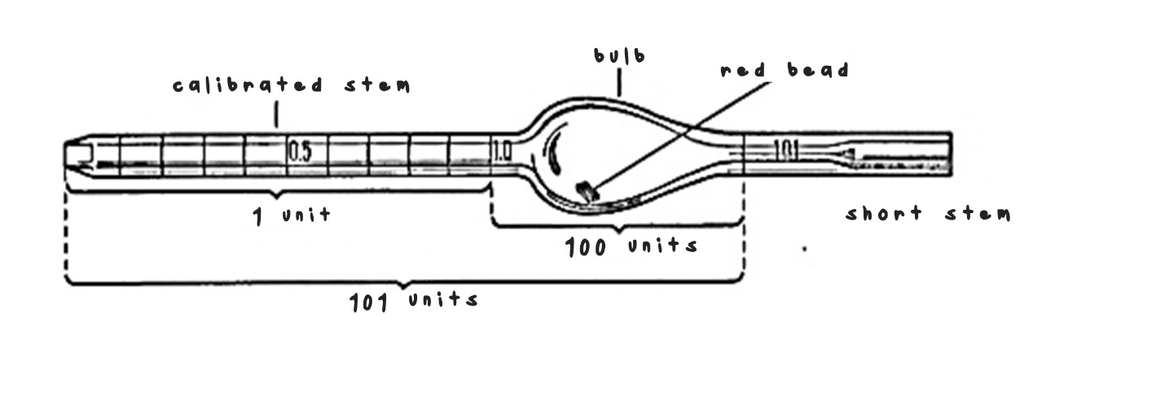

B. WBC Thoma Pipette



