First go to coin.ph application download na lng kau sa playstore.. or kung pc bahala ka na eh mas madali sa pc diba!!!
convert any amount min. 5php to btc kahit ilan invest mo..
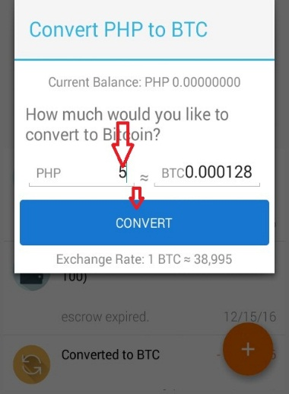 next copy nyo yung btc address nyo sa req. 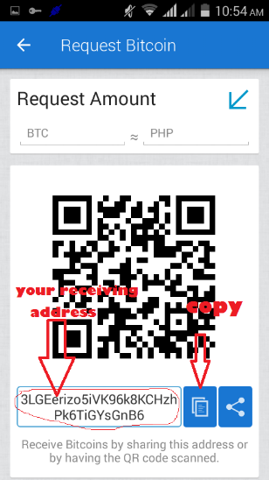
Now go click this link https://quickbtc.net/?aff=f68e09b1d6a
Para mapunta kayu dito paste nyo yung btc address nyo
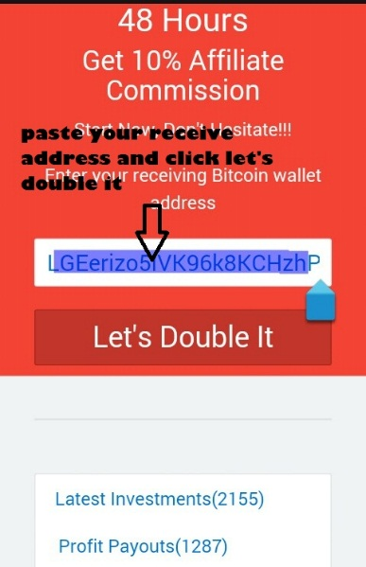next is lalabas yan. 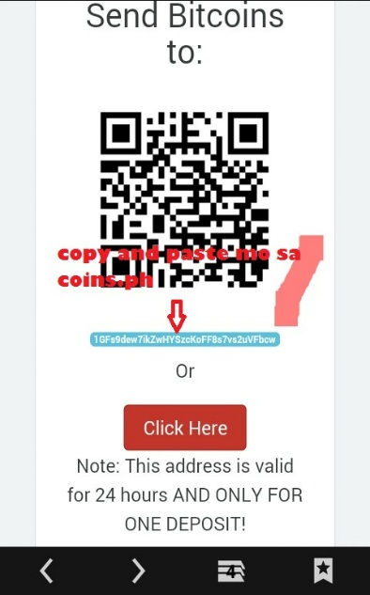copy btc address jan nyo send ang payment mo

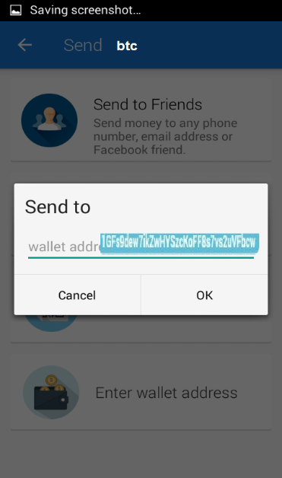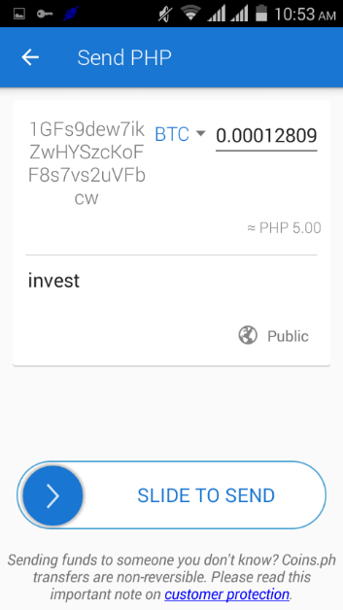 my investment 

